**MODERN ACADEMY**

**FOR ENGINEERING & TECHNOLOGY**

**Computer Department**

**Academic Year 2023/2024**

**December 2023**



**Toolbox Documentation**

**Course Title: Digital image processing**

**Course Code: CMPN332**

|  |  |
| --- | --- |
| Name | Youssef Ahmed Saied |
| Section | **2** |
| ID | **4200479** |
| Dr | **Sabry Mohamed Abdelmoaty** |

Content:

1. Installing
2. Initialize
3. Source Code
4. Final View of the program
5. Every button and component in the program

First Installing the program:

1. These is the link of python to install first

<https://www.python.org/ftp/python/3.12.1/python-3.12.1-amd64.exe>

1. Then setup program by clicking next to begin setup process.
2. Download visual studio code

<https://code.visualstudio.com/download>  
  
Then install it

1. Open visual studio code and download python extensions

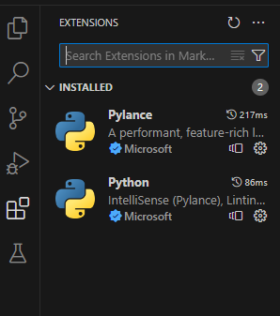

1. Download The needed libirares

Second initializing the program:

#-----Includes------

import customtkinter as ctk

import tkinter as tk

from tkinter import filedialog ,simpledialog

import cv2

from tkinter import Canvas

from PIL import Image , ImageTk, ImageDraw

import numpy as np

import os

import subprocess

import os

from matplotlib import pyplot as plt

Third Source Code:

class Main(ctk.CTk):

    def __init__(self):

        super().__init__()

        #------Setup------

        self.title('ToolBox')

        self.geometry('1366x768')

        #------variable------

        self.image = None

        self.image2 = None

        self.original = None

        self.rotate_angle = ctk.IntVar(value=0)

        self.rotate_angle.trace('w' , self.rotate_image)

        self.scale_factor_x = 1.0

        self.scale_factor_y = 1.0

        self.scale_factors = ctk.StringVar(value="0.0:0.0")

        self.skew_factor_x = 1.0

        self.skew_factor_y = 1.0

        self.trans_factor_x = 0

        self.trans_factor_y = 0

        self.blur_angle = ctk.IntVar(value=0)

        self.blur_angle.trace('w' , self.blur_image)

        self.threshold = 0

        self.blend_factor_x = 0

        self.blend_factor_y = 0

        self.crop_start_factor_x  = 0

        self.crop_start_factor_y  = 0

        self.crop_width_factor_x  = 0

        self.crop_height_factor_y = 0

        #------Frames--------

        #Left Frame

        L_frame = ctk.CTkFrame(master = self , corner_radius = 0 , fg_color = '#212121')

        L_frame.place(relx = 0 , rely = 0 , relwidth = 0.2 , relheight = 1)

        #Right Frame

        frame1 = ctk.CTkFrame(master = self , corner_radius = 0 , fg_color = '#212121')

        frame1.place(relx = 0.2 , rely = 0 , relwidth = 0.2 , relheight = 1)

            #Frame1

        R_frame = ctk.CTkFrame(master = frame1 , fg_color = '#212121')

        R_frame.pack(fill = 'x' , expand = True, padx = 8 , pady = 8 )

            #Frame2

        frame2 = ctk.CTkFrame(master = L_frame , fg_color = '#212121')

        frame2.pack(fill = 'x' , padx = 8 , pady = 8 , expand = True)

            #Frame3

        frame3 = ctk.CTkFrame(master = L_frame , corner_radius = 0 , fg_color = 'transparent' )

        frame3.pack(fill = 'x' , expand = True)

            #Frame4

        frame4 = ctk.CTkFrame(master = self , corner_radius = 0 , fg_color = '#212121' )

        frame4.place(relx = 0.4 , rely = 0.8 , relwidth = 0.2 , relheight = 0.2)

        #MID Frame

            #------Canvas------

        self.canvas = Canvas(master=self)

        self.canvas.place(relx = 0.4 , rely = 0 , relwidth = 0.6 , relheight = 0.8)

        #Bottum Frame

        B_frame = ctk.CTkFrame(master = self , corner_radius = 0 , fg_color = '#212121')

        B_frame.place(relx = 0.6 , rely = 0.8 , relwidth = 0.4 , relheight = 0.2)

        #--------Main Buttons-------

        btn_frame = ctk.CTkFrame(master = B_frame , fg_color = '#111111')

        btn_frame.pack(fill = 'x' , expand = True )

            # Configure of row

        btn_frame.rowconfigure((0,1,2) , weight=1 , uniform='a')

            # Configure of column

        btn_frame.columnconfigure((0) , weight=1 , uniform='a')

            #Browse Button

        browse_button = ctk.CTkButton(master = btn_frame , text= 'Browse' , command=self.load_image, fg_color = '#44D62C',hover_color='#65e650',text_color='Black')

        browse_button.grid(row = 0 , column = 0  , padx = 8 , pady = 8, sticky = 'ew')

            #Reset Button

        reset_button = ctk.CTkButton(master = btn_frame , text= 'Reset' , command= self.reset_image, fg_color = '#44D62C',hover_color='#65e650',text_color='Black')

        reset_button.grid(row = 1 , column = 0 , padx = 8 , pady = 8, sticky = 'ew')

            #Export Button

        export_button = ctk.CTkButton(master = btn_frame , text= 'Export' , command= self.save_image, fg_color = '#44D62C',hover_color='#65e650',text_color='Black')

        export_button.grid(row = 2 , column = 0  , padx = 8 , pady = 8, sticky = 'ew')

        #---------Rotate Frame--------

        rotate_frame = ctk.CTkFrame(master = frame2 , fg_color = '#111111')

        rotate_frame.pack(fill = 'x' , expand = True , padx = 8 , pady = 8)

            # Configure of row

        rotate_frame.rowconfigure((0,1) , weight=1 , uniform='a')

            # Configure of column

        rotate_frame.columnconfigure((0,1) , weight=1 , uniform='a')

            # Rotate label

        ratate_label = ctk.CTkLabel(master=rotate_frame , text = 'Rotate Image',text_color='white')

        ratate_label.grid(row = 0 , column = 0 , padx = 8 , pady = 8 , sticky = 'w')

            # Rotate label angle

        ratate_angle_label = ctk.CTkLabel(master=rotate_frame , textvariable = self.rotate_angle)

        ratate_angle_label.grid(row = 0 , column = 1 , padx = 8 , pady = 8 , sticky = 'e')

            # Slider

        rotate_slider = ctk.CTkSlider(master=rotate_frame , from_=0 , to= 360 , variable=self.rotate_angle, fg_color = 'black',button_hover_color='#65e650',progress_color='#44D62C',button_color='#44D62C')

        rotate_slider.grid(row = 1 , column = 0 , columnspan = 2 , padx = 8 , pady  = 8 , sticky = 'ew')

        #Skew Image

        skew_frame = ctk.CTkFrame(master = frame2 , fg_color = '#111111')

        skew_frame.pack(fill = 'x' , expand = True , padx = 8 , pady = 8)

            # Configure of row

        skew_frame.rowconfigure((0,1) , weight=1 , uniform='a')

            # Configure of column

        skew_frame.columnconfigure((0,1) , weight=1 , uniform='a')

            # Skew label

        skew_label = ctk.CTkLabel(master=skew_frame , text = 'Skew Image',text_color='white')

        skew_label.grid(row = 0 , column = 0 , padx = 8 , pady = 8 , sticky = 'w')

            # Skew label angle

        #---Buttons

        skew_button1 = ctk.CTkButton(master = skew_frame , text= 'Skew X' , command= lambda:self.skew_image('x'), fg_color = '#44D62C',hover_color='#65e650',text_color='Black')

        skew_button1.grid(row = 1 , column = 0 , padx = 8 , pady = 8)

        skew_button2 = ctk.CTkButton(master = skew_frame , text= 'Skew Y' , command= lambda:self.skew_image('y'), fg_color = '#44D62C',hover_color='#65e650',text_color='Black')

        skew_button2.grid(row = 1 , column = 1 , padx = 8 , pady = 8)

        #-------------------------------------------------------

        # Translation

        tran_frame = ctk.CTkFrame(master = frame2 , fg_color = '#111111')

        tran_frame.pack(fill = 'x' , expand = True , padx = 8 , pady = 8)

            # Configure of row

        tran_frame.rowconfigure((0,1) , weight=1 , uniform='a')

            # Configure of column

        tran_frame.columnconfigure((0,1) , weight=1 , uniform='a')

            # Translation label

        trans_label = ctk.CTkLabel(master=tran_frame , text = 'Translation',text_color='white')

        trans_label.grid(row = 0 , column = 0 , padx = 8 , pady = 8 , sticky = 'w')

            # Translation label angle

        #---Buttons Translation

        trans_button1 = ctk.CTkButton(master = tran_frame , text= 'Translate X' , command= lambda:self.trans_image('x'), fg_color = '#44D62C',hover_color='#65e650',text_color='Black')

        trans_button1.grid(row = 1 , column = 0 , padx = 8 , pady = 8)

        trans_button2 = ctk.CTkButton(master = tran_frame , text= 'Translate Y' , command= lambda:self.trans_image('y'), fg_color = '#44D62C',hover_color='#65e650',text_color='Black')

        trans_button2.grid(row = 1 , column = 1 , padx = 8 , pady = 8)

        #-------------------------------------------------------

        #---------Scale Frame--------

        scale_frame = ctk.CTkFrame(master = frame2 , fg_color = '#111111')

        scale_frame.pack(fill = 'x' , expand = True , padx = 8 , pady = 8)

            # Configure of row

        scale_frame.rowconfigure((0,1) , weight=1 , uniform='a')

            # Configure of column

        scale_frame.columnconfigure((0,1) , weight=1 , uniform='a')

            # Scale label

        scale_label = ctk.CTkLabel(master=scale_frame , text = 'Scale',text_color='white')

        scale_label.grid(row = 0 , column = 0 , padx = 8 , pady = 8 , sticky = 'w')

            # Scale Factors

        scale_fac_label = ctk.CTkLabel(master=scale_frame , textvariable = self.scale_factors)

        scale_fac_label.grid(row = 0 , column = 1 , padx = 8 , pady = 8 , sticky = 'e')

            #Scale X Button

        scale_x_button = ctk.CTkButton(master = scale_frame , text= 'Scale X' , command=lambda:self.scale_image("x"), fg_color = '#44D62C',hover_color='#65e650',text_color='Black')

        scale_x_button.grid(row = 1 , column = 0 , padx = 8 , pady = 8 , sticky = 'e')

            #Scale Y Button

        scale_y_button = ctk.CTkButton(master = scale_frame , text= 'Scale Y' , command=lambda:self.scale_image("y"), fg_color = '#44D62C',hover_color='#65e650',text_color='Black')

        scale_y_button.grid(row = 1 , column = 1 , padx = 8 , pady = 8 , sticky = 'w')

        #---------Flip Frame--------

        flip_frame = ctk.CTkFrame(master = frame2 , fg_color = '#111111')

        flip_frame.pack(fill = 'x' , expand = True , padx = 8 , pady = 8)

            # Configure of row

        flip_frame.rowconfigure((0,1) , weight=1 , uniform='a')

            # Configure of column

        flip_frame.columnconfigure((0,1,2) , weight=1 , uniform='a')

                    # Flip label

        scale_label = ctk.CTkLabel(master=flip_frame , text = 'Flip',text_color='white')

        scale_label.grid(row = 0 , column = 0 , padx = 8 , pady = 8 , sticky = 'w')

            #Flip X Button

        scale_x_button = ctk.CTkButton(master = flip_frame , text= 'X' , command=lambda:self.flip_image('x'), fg_color = '#44D62C',hover_color='#65e650',text_color='Black')

        scale_x_button.grid(row = 1 , column = 0 , padx = 8 , pady = 8 )

            #Flip Y Button

        scale_y_button = ctk.CTkButton(master = flip_frame , text= 'Y' , command=lambda:self.flip_image('y'), fg_color = '#44D62C',hover_color='#65e650',text_color='Black')

        scale_y_button.grid(row = 1 , column = 1 , padx = 8 , pady = 8 )

            #Flip Y Button

        scale_y_button = ctk.CTkButton(master = flip_frame , text= 'Both' , command=lambda:self.flip_image('b'), fg_color = '#44D62C',hover_color='#65e650',text_color='Black')

        scale_y_button.grid(row = 1 , column = 2 , padx = 8 , pady = 8 )

        #---------Filter Frame--------

        filter_frame = ctk.CTkFrame(master = frame2 , fg_color = '#111111')

        filter_frame.pack(fill = 'x' , expand = True , padx = 8 , pady = 8)

            # Configure of row

        filter_frame.rowconfigure((0,1) , weight=1 , uniform='a')

            # Configure of column

        filter_frame.columnconfigure((0) , weight=1 , uniform='a')

            # Filter label

        filter_label = ctk.CTkLabel(master=filter_frame , text = 'Filters',text_color='white')

        filter_label.grid(row = 0 , column = 0 , padx = 8 , pady = 8 , sticky = 'w')

            #Filter Drop Down Button

        filter_drop_down_button = ctk.CTkOptionMenu(filter_frame , values = ["Select", "Grayscale" , "Invert" , "Median Filter" ,"Averaging" ,"Laplacian" , "Edge Detection"] , command=self.filter_image, fg_color = '#44D62C',button_color='#44D62C',button_hover_color='#65e650',dropdown_hover_color='gray',text_color='black')

        filter_drop_down_button.grid(row = 1 , column = 0 , padx = 8 , pady = 8 , sticky = 'ew' )

        # ------Zoom----

        zoom_frame = ctk.CTkFrame(master = frame2 , fg_color = '#111111')

        zoom_frame.pack(fill = 'x' , expand = True , padx = 8 , pady = 8)

            # Configure of row

        zoom_frame.rowconfigure((0,1) , weight=1 , uniform='a')

            # Configure of column

        zoom_frame.columnconfigure((0) , weight=1 , uniform='a')

            # zoom label

        zoom_label = ctk.CTkLabel(master=zoom_frame , text = 'Croping',text_color='white')

        zoom_label.grid(row = 0 , column = 0 , padx = 8 , pady = 8 , sticky = 'w')

            # Zoom Button

        zoom_button = ctk.CTkButton(master = zoom_frame , text= 'Crop' , command=self.zoom_image, fg_color = '#44D62C',hover_color='#65e650',text_color='Black',font=('Bold',15))

        zoom_button.grid(row = 1, column = 0 , padx = 8 , pady = 8 , sticky = 'ew')

        #---------Bit Plan Frame--------

        bit_frame = ctk.CTkFrame(master = R_frame , fg_color = '#111111')

        bit_frame.pack(fill = 'x' , expand = True , padx = 8 , pady = 8)

            # Configure of row

        bit_frame.rowconfigure((0,1) , weight=1 , uniform='a')

            # Configure of column

        bit_frame.columnconfigure((0) , weight=1 , uniform='a')

            # Bit Plan label

        bit_label = ctk.CTkLabel(master=bit_frame , text = 'Bit plan',text_color='white')

        bit_label.grid(row = 0 , column = 0 , padx = 8 , pady = 8 , sticky = 'w')

            #Bit Plan Drop Down Button

        bit_drop_down_button = ctk.CTkOptionMenu(bit_frame , values = ["Select" ,"128" , "64" , "32" , "16" , "8", "4" , "2" , "1"] , command=self.bit_image, fg_color = '#44D62C',button_color='#44D62C',button_hover_color='#65e650',dropdown_hover_color='gray',text_color='black')

        bit_drop_down_button.grid(row = 1 , column = 0 , padx = 8 , pady = 8 , sticky = 'ew' )

        #---------Power Frame--------

        pow_frame = ctk.CTkFrame(master = R_frame , fg_color = '#111111')

        pow_frame.pack(fill = 'x' , expand = True , padx = 8 , pady = 8)

            # Configure of row

        pow_frame.rowconfigure((0,1) , weight=1 , uniform='a')

            # Configure of column

        pow_frame.columnconfigure((0) , weight=1 , uniform='a')

            # Power label

        bit_label = ctk.CTkLabel(master=pow_frame , text = 'Power Transformation',text_color='white')

        bit_label.grid(row = 0 , column = 0 , padx = 8 , pady = 8 , sticky = 'w')

            #Power Drop Down Button

        pow_drop_down_button = ctk.CTkOptionMenu(pow_frame , values = ["Select" , "0.1" , "0.4" , "0.8" , "1.2" , "1.6", "2" ] , command=self.power_image, fg_color = '#44D62C',button_color='#44D62C',button_hover_color='#65e650',dropdown_hover_color='gray',text_color='black')

        pow_drop_down_button.grid(row = 1 , column = 0 , padx = 8 , pady = 8 , sticky = 'ew' )

        #---------Sharping Frame--------

        sharp_frame = ctk.CTkFrame(master = R_frame , fg_color = '#111111')

        sharp_frame.pack(fill = 'x' , expand = True , padx = 8 , pady = 8)

            # Configure of row

        sharp_frame.rowconfigure((0,1) , weight=1 , uniform='a')

            # Configure of column

        sharp_frame.columnconfigure((0,1,2) , weight=1 , uniform='a')

                    # Flip label

        sharp_label = ctk.CTkLabel(master=sharp_frame , text = 'Sharping',text_color='white')

        sharp_label.grid(row = 0 , column = 0 , padx = 8 , pady = 8 , sticky = 'w')

            #sharp X Button

        scale_x_button = ctk.CTkButton(master = sharp_frame , text= 'Middle' , command=lambda:self.sharp_image('l'), fg_color = '#44D62C',hover_color='#65e650',text_color='Black')

        scale_x_button.grid(row = 1 , column = 1 , padx = 8 , pady = 8 )

            #sharp Y Button

        scale_y_button = ctk.CTkButton(master = sharp_frame , text= 'High' , command=lambda:self.sharp_image('m'), fg_color = '#44D62C',hover_color='#65e650',text_color='Black')

        scale_y_button.grid(row = 1 , column = 2 , padx = 8 , pady = 8 )

            #sharp Y Button

        scale_y_button = ctk.CTkButton(master = sharp_frame , text= 'Low' , command=lambda:self.sharp_image('h'), fg_color = '#44D62C',hover_color='#65e650',text_color='Black')

        scale_y_button.grid(row = 1 , column = 0 , padx = 8 , pady = 8 )

       #---------Blur Frame--------

        blur_frame = ctk.CTkFrame(master = R_frame , fg_color = '#111111')

        blur_frame.pack(fill = 'x' , expand = True , padx = 8 , pady = 8)

            # Configure of row

        blur_frame.rowconfigure((0,1) , weight=1 , uniform='a')

            # Configure of column

        blur_frame.columnconfigure((0,1) , weight=1 , uniform='a')

            # Blur label

        blur_label = ctk.CTkLabel(master=blur_frame , text = 'Gaussian Blur',text_color='white')

        blur_label.grid(row = 0 , column = 0 , padx = 8 , pady = 8 , sticky = 'w')

            # Blur label angle

        blur_angle_label = ctk.CTkLabel(master=blur_frame , textvariable = self.blur_angle)

        blur_angle_label.grid(row = 0 , column = 1 , padx = 8 , pady = 8 , sticky = 'e')

            # Slider

        blur_slider = ctk.CTkSlider(master=blur_frame , from_=0 , to= 50 , variable=self.blur_angle,fg_color = 'black',button_hover_color='#65e650',progress_color='#44D62C',button_color='#44D62C')

        blur_slider.grid(row = 1 , column = 0 , columnspan = 2 , padx = 8 , pady  = 8 , sticky = 'ew')

        #---------threshold Frame--------

        threshold_frame = ctk.CTkFrame(master = R_frame , fg_color = '#111111')

        threshold_frame.pack(fill = 'x' , expand = True , padx = 8 , pady = 8)

            # Configure of row

        threshold_frame.rowconfigure((0,1) , weight=1 , uniform='a')

            # Configure of column

        threshold_frame.columnconfigure((0) , weight=1 , uniform='a')

            # threshold label

        threshold_label = ctk.CTkLabel(master=threshold_frame , text = 'Threshold',text_color='white')

        threshold_label.grid(row = 0 , column = 0 , padx = 8 , pady = 8 , sticky = 'w')

            # Button

        threshold_button = ctk.CTkButton(master = threshold_frame , text= 'Range' , command=self.threshold_image, fg_color = '#44D62C',hover_color='#65e650',text_color='Black')

        threshold_button.grid(row = 1 , column = 0 , padx = 8 , pady = 8 , sticky = 'ew' )

        #---------Sobel Frame--------

        sobel_frame = ctk.CTkFrame(master = R_frame , fg_color = '#111111')

        sobel_frame.pack(fill = 'x' , expand = True , padx = 8 , pady = 8)

            # Configure of row

        sobel_frame.rowconfigure((0,1) , weight=1 , uniform='a')

            # Configure of column

        sobel_frame.columnconfigure((0,1,2) , weight=1 , uniform='a')

                    # Flip label

        sobel_label = ctk.CTkLabel(master=sobel_frame , text = 'Sobel Filter',text_color='white')

        sobel_label.grid(row = 0 , column = 0 , padx = 8 , pady = 8 , sticky = 'w')

            #Flip X Button

        sobel_x_button = ctk.CTkButton(master = sobel_frame , text= 'X' , command=lambda:self.sobel_image('x'), fg_color = '#44D62C',hover_color='#65e650',text_color='Black')

        sobel_x_button.grid(row = 1 , column = 0 , padx = 8 , pady = 8 )

            #Flip Y Button

        sobel_y_button = ctk.CTkButton(master = sobel_frame , text= 'Y' , command=lambda:self.sobel_image('y'), fg_color = '#44D62C',hover_color='#65e650',text_color='Black')

        sobel_y_button.grid(row = 1 , column = 1 , padx = 8 , pady = 8 )

            #Flip Y Button

        sobel_b_button = ctk.CTkButton(master = sobel_frame , text= 'Both' , command=lambda:self.sobel_image('b'), fg_color = '#44D62C',hover_color='#65e650',text_color='Black')

        sobel_b_button.grid(row = 1 , column = 2 , padx = 8 , pady = 8 )

        # ----blend----

        blend_frame = ctk.CTkFrame(master = R_frame , fg_color = '#111111')

        blend_frame.pack(fill = 'x' , expand = True , padx = 8 , pady = 8)

            # Configure of row

        blend_frame.rowconfigure((0,1) , weight=1 , uniform='a')

            # Configure of column

        blend_frame.columnconfigure((0) , weight=1 , uniform='a')

            # blend label

        blend_label = ctk.CTkLabel(master=blend_frame , text = 'Blending',text_color='white')

        blend_label.grid(row = 0 , column = 0 , padx = 8 , pady = 8 , sticky = 'w')

            # blend Button

        blend_button = ctk.CTkButton(master = blend_frame , text= 'blend' , command=self.blend_image, fg_color = '#44D62C',hover_color='#65e650',text_color='Black')

        blend_button.grid(row = 1, column = 0 , padx = 8 , pady = 8 , sticky = 'ew')

        # ----OCR----

        ocr_frame = ctk.CTkFrame(master = frame4 , fg_color = '#111111')

        ocr_frame.pack(fill = 'x' , expand = True , padx = 8 , pady = 8)

            # Configure of row

        ocr_frame.rowconfigure((0,1) , weight=1 , uniform='a')

            # Configure of column

        ocr_frame.columnconfigure((0) , weight=1 , uniform='a')

            # ocr label

        ocr_label = ctk.CTkLabel(master=ocr_frame , text = 'OCR',text_color='white')

        ocr_label.grid(row = 0 , column = 0 , padx = 8 , pady = 8 , sticky = 'w')

            # ocr Button

        ocr_button = ctk.CTkButton(master = ocr_frame , text= 'OCR' ,command=self.ocr , fg_color = '#44D62C',hover_color='#65e650',text_color='Black')

        ocr_button.grid(row = 1, column = 0 , padx = 8 , pady = 8 , sticky = 'ew')

    #Load image function ( Browse )

    def load_image(self):

        file_path = filedialog.askopenfilename(filetypes=[("Select An Image" , "*.png;*.jpg;*.jpeg")])

        if file_path :

            self.original = cv2.imread(file_path)

            self.image = self.original

            self.display_image()

    def load_image2(self):

        file_path = filedialog.askopenfilename(filetypes=[("Select An Image" , "*.png;*.jpg;*.jpeg")])

        if file_path :

            self.image2 = cv2.imread(file_path)

    # Display Image function

    def display_image(self):

        if self.image is not None :

            rgb_image = cv2.cvtColor(self.image , cv2.COLOR_BGR2RGB)

            tk_image = ImageTk.PhotoImage(Image.fromarray(rgb_image))

            self.canvas.create_image(0 , 0 , anchor = 'nw' , image = tk_image)

            self.canvas.tk_image = tk_image

    #Rotate image

    def rotate_image(self , *arg):

        if self.image is not None :

            center = (self.image.shape[1] // 2,self.image.shape[0] // 2) # to get center of image

            rotation_matrix = cv2.getRotationMatrix2D(center , self.rotate_angle.get(), 1.0)

            self.image = cv2.warpAffine(self.original , rotation_matrix , (self.image.shape[1] , self.image.shape[0] ))

            self.display_image()

    #Scale image

    def scale_image(self , scale):

        if self.image is not None :

            if scale == 'x':

                self.scale_factor_x = simpledialog.askfloat("Scale X" , "Enter scale for X direction:" , initialvalue = self.scale_factor_x)

            elif scale == 'y':

                self.scale_factor_y = simpledialog.askfloat("Scale Y" , "Enter scale for Y direction:" , initialvalue = self.scale_factor_y)

            self.scale_factors.set(f"{self.scale_factor_x} : {self.scale_factor_y}")

            self.image = cv2.resize(self.original , (0,0) , fx=self.scale_factor_x , fy = self.scale_factor_y)

            self.display_image()

    #----------Skewing---------------

    def skew_image(self , skew):

        if self.image is not None :

            height, width = self.image.shape[:2]

            if skew =='x':

                self.skew_factor_x = simpledialog.askfloat("Skew X" , "Enter skew for X direction:" , initialvalue = self.skew_factor_x)

                pts1 = np.float32([[0, 0], [width - 1, 0], [0, height - 1], [width - 1, height - 1]])

                pts2 = np.float32([[-self.skew_factor_x, 0], [width - 1 - self.skew_factor_x, 0], [self.skew_factor_x, height - 1], [width - 1, height - 1]])

                matrix = cv2.getPerspectiveTransform(pts1, pts2)

                self.image = cv2.warpPerspective(self.image, matrix, (width, height))

                #----------------------

            elif skew =='y':

                self.skew_factor_y = simpledialog.askfloat("Skew Y" , "Enter skew for Y direction:" , initialvalue = self.skew_factor_y)

                pts1 = np.float32([[0, 0], [width - 1, 0], [0, height - 1], [width - 1, height - 1]])

                pts2 = np.float32([[0, -self.skew_factor_y], [width - 1, self.skew_factor_y], [0, height - 1 -self.skew_factor_y], [width - 1 , height -1 + self.skew_factor_y]])

                matrix = cv2.getPerspectiveTransform(pts1, pts2)

                self.image = cv2.warpPerspective(self.image, matrix, (width, height))

            self.display_image()

    #-------------------------------------------------------

    #----------Skewing---------------

    def trans_image(self , trans):

        if self.image is not None :

            height, width = self.image.shape[:2]

            if trans =='x':

                self.trans_factor_x = simpledialog.askfloat("Translate X" , "Enter Translate value for X direction:" , initialvalue = self.trans_factor_x)

                translation_matrix = np.float32([[1, 0, self.trans_factor_x], [0, 1, 0]])

                self.image = cv2.warpAffine(self.image, translation_matrix, (width, height))

                #----------------------

            elif trans =='y':

                self.trans_factor_y = simpledialog.askfloat("Translate Y" , "Enter Translate value for Y direction:" , initialvalue = self.trans_factor_y)

                translation_matrix = np.float32([[1, 0, 0], [0, 1, self.trans_factor_x]])

                self.image = cv2.warpAffine(self.image, translation_matrix, (width, height))

            self.display_image()

    #-------------------------------------------------------

    #flip Image

    def flip_image(self , flip):

        if self.image is not None :

            if flip == 'x':

                self.image = cv2.flip(self.image , 1 )

            elif flip == 'y':

                self.image = cv2.flip(self.image , 0 )

            elif flip == 'b':

                self.image = cv2.flip(self.image , -1 )

            self.display_image()

    # Split Colors

    def split_color(self , color):

        if self.image is not None :

            r , g , b = cv2.split(self.image)

            blank = np.zeros(self.image.shape[:2] , dtype = "uint8")

            if color == 'Red':

                self.image = cv2.merge([blank,blank,r])

            elif color == 'Green':

                self.image = cv2.merge([blank,blank,g])

            elif color == 'Blue':

                self.image = cv2.merge([blank,blank,b])

            self.display_image()

    # Filter Image

    def filter_image(self , event):

        if self.image is not None :

            if event == "None" :

                self.image = self.original

            elif event == "Grayscale" :

                self.image = cv2.cvtColor(self.image,cv2.COLOR_BGR2GRAY)

            elif event == "Invert" :

                self.image = 255 - self.image

            elif event == "Median Filter" :

                self.image = cv2.medianBlur(self.image , 5)

            elif event == "Averaging" :

                self.image = cv2.cvtColor(self.image,cv2.COLOR_BGR2GRAY)

                kernel_size = (3, 3)

                kernel = (1.0 / (kernel_size[0] * kernel_size[1])) * np.ones(kernel_size, dtype=np.float32)

                self.image = cv2.filter2D(self.image, -1, kernel)

            elif event == "Laplacian" :

                self.image = cv2.cvtColor(self.image,cv2.COLOR_BGR2GRAY)

                laplacian_kernel = np.array([[0, -1, 0],[-1, 4, -1],[0, -1, 0]], dtype=np.float32)

                self.image = cv2.filter2D(self.image, -1, laplacian_kernel)

            elif event == "Edge Detection":

                self.image = cv2.cvtColor(self.image,cv2.COLOR_BGR2GRAY)

                kernel_L = np.array([[-1, -1, -1], [-1, 8, -1], [-1, -1, -1]], dtype=np.float32)

                self.image = cv2.filter2D(self.image, cv2.CV_8UC1, kernel_L)

            self.display_image()

    # Zooming

    def zoom_image(self):

        if self.image is not None :

            self.crop_start_factor_x = simpledialog.askinteger("X point" , "Enter start point for X direction:" , initialvalue = self.crop_start_factor_x)

            self.crop_start_factor_y = simpledialog.askinteger("Y point" , "Enter start point for Y direction:" , initialvalue = self.crop_start_factor_y)

            self.crop_width_factor_x = simpledialog.askinteger("Width" , "Enter width of crop image:" , initialvalue = self.crop_width_factor_x)

            self.crop_height_factor_y = simpledialog.askinteger("Height" , "Enter height of crop image:" , initialvalue = self.crop_height_factor_y)

            x, y, width, height = self.crop_start_factor_x, self.crop_start_factor_y, self.crop_width_factor_x, self.crop_height_factor_y

            self.image = self.image[y:y+height, x:x+width]

            self.display_image()

    # Bit Plan

    def bit_image(self , event):

        if self.image is not None :

            lst = []

            for row in range(self.image.shape[0]):

                for col in range(self.image.shape[1]):

                    lst.append(np.binary_repr(self.image[row][col] ,width=8))

            if event == '128':

                self.image = (np.array([int(i[0]) for i in lst],dtype = np.uint8) * 128).reshape(self.image.shape[0],self.image.shape[1])

            elif event == '64':

                self.image = (np.array([int(i[1]) for i in lst],dtype = np.uint8) * 64).reshape(self.image.shape[0],self.image.shape[1])

            elif event == '32':

                self.image = (np.array([int(i[2]) for i in lst],dtype = np.uint8) * 32).reshape(self.image.shape[0],self.image.shape[1])

            elif event == '16':

                self.image = (np.array([int(i[3]) for i in lst],dtype = np.uint8) * 16).reshape(self.image.shape[0],self.image.shape[1])

            elif event == '8':

                self.image = (np.array([int(i[4]) for i in lst],dtype = np.uint8) * 8).reshape(self.image.shape[0],self.image.shape[1])

            elif event == '4':

                self.image = (np.array([int(i[5]) for i in lst],dtype = np.uint8) * 4).reshape(self.image.shape[0],self.image.shape[1])

            elif event == '2':

                self.image = (np.array([int(i[6]) for i in lst],dtype = np.uint8) * 2).reshape(self.image.shape[0],self.image.shape[1])

            elif event == '1':

                self.image = (np.array([int(i[7]) for i in lst],dtype = np.uint8) * 1).reshape(self.image.shape[0],self.image.shape[1])

            self.display_image()

    # Power Transformation

    def power_image(self , event):

        if self.image is not None :

            if event == '0.1':

                arr = np.array(255*(self.image/255)**0.1,dtype='uint8')

            elif event == '0.4':

                arr = np.array(255*(self.image/255)**0.4,dtype='uint8')

            elif event == '0.8':

                arr = np.array(255*(self.image/255)**0.8,dtype='uint8')

            elif event == '1.2':

                arr = np.array(255*(self.image/255)**1.2,dtype='uint8')

            elif event == '1.6':

                arr = np.array(255*(self.image/255)**1.6,dtype='uint8')

            elif event == '2':

                arr = np.array(255*(self.image/255)**2,dtype='uint8')

            cv2.normalize(arr,arr,0,255,cv2.NORM_MINMAX)

            cv2.convertScaleAbs(arr,arr)

            self.image = arr

            self.display_image()

    #Sharp Image

    def sharp_image(self , sharp):

        if self.image is not None :

            if sharp == 'l':

                kernal_shearing = np.array([[-1, -1, -1],[-1, 9, -1],[-1, -1, -1]])

                self.image = cv2.filter2D(self.image, -1, kernal_shearing)

            elif sharp == 'm':

                kernal_shearing = np.array([[1, 1, 1],[1, -7, 1],[1, 1, 1]])

                self.image = cv2.filter2D(self.image, -1, kernal_shearing)

            elif sharp == 'h':

                kernal_shearing = np.array([[-1,-1,-1,-1,-1],

                             [-1,2,2,2,-1],

                             [-1,2,8,2,-1],

                             [-1,2,2,2,-1],

                             [-1,-1,-1,-1,-1]]) / 8.0

                self.image = cv2.filter2D(self.image, -1, kernal_shearing)

            self.display_image()

    # Blur

    def blur_image(self , *arg):

        if self.image is not None :

            var = self.blur_angle.get()

            self.image = cv2.GaussianBlur(self.image , (var,var) , 0)

            self.display_image()

   # Threshold

    def threshold_image(self):

        if self.image is not None :

            self.threshold = simpledialog.askinteger("Threshould" , "---" , initialvalue = self.threshold)

            self.image = cv2.cvtColor(self.image , cv2.COLOR_BGR2GRAY)

            ret , self.image = cv2.threshold(self.image , self.threshold,self.threshold, 0)

            self.display_image()

    # Sobel

    def sobel_image(self,sobel):

        if self.image is not None :

            self.image = cv2.cvtColor(self.image, cv2.COLOR_BGR2GRAY)

            if sobel == 'x':

                self.image = cv2.Sobel(self.image , cv2.CV_8U , 1 , 0 , 3 )

            elif sobel == 'y':

                self.image = cv2.Sobel(self.image , cv2.CV_8U , 0 , 1 , 3 )

            elif sobel == 'b':

                self.image = cv2.Sobel(self.image , cv2.CV_8U , 1 , 1 , 3 )

            self.display_image()

    #Reset Image

    def reset_image(self):

        if self.image is not None :

            self.image = self.original

            self.scale_factor_x = 1.0

            self.scale_factor_y = 1.0

            self.scale_factors.set(f"{self.scale_factor_x} : {self.scale_factor_y}")

            self.display_image()

    #blend

    def blend_image(self):

        if self.image is not None :

            height, width = self.image.shape[:2]

            self.load_image2()

            self.blend_factor_x = simpledialog.askfloat("Ratio" , "Enter ratio of first image:" , initialvalue = self.blend_factor_x)

            self.blend_factor_y = simpledialog.askfloat("Ratio" , "Enter ratio of second image:" , initialvalue = self.blend_factor_y)

            self.image2 = cv2.resize(self.image2,(width,height))

            for row in range(height):

                for col in range(width):

                    self.image[row,col] = self.image[row,col] * self.blend_factor_x + self.image2[row,col] * self.blend_factor_y

            self.display_image()

    def ocr(self):

        try:

            subprocess.run(["python", "Main.py"], check=True)

            print("Main.py executed successfully")

        except subprocess.CalledProcessError as e:

            print("Error executing Main.py:", e)

    #Save image function ( Export )

    def save_image(self):

        if self.image is not None :

            file_path = filedialog.asksaveasfilename(title="Save Image" ,defaultextension=".png" ,filetypes=[("PNG files" , "*.png")])

        if file_path:

            cv2.imwrite(file_path , self.image)

if __name__=='__main__':

    app = Main()

    app.mainloop()

OCR

#-----Includes------

import customtkinter as ctk

import tkinter as tk

from tkinter import filedialog ,simpledialog

import cv2

from tkinter import Canvas

from PIL import Image , ImageTk, ImageDraw

import numpy as np

import os

import DetectChars

import DetectPlates

import PossiblePlate

# module level variables ##########################################################################

SCALAR_BLACK = (0.0, 0.0, 0.0)

SCALAR_WHITE = (255.0, 255.0, 255.0)

SCALAR_YELLOW = (0.0, 255.0, 255.0)

SCALAR_GREEN = (0.0, 255.0, 0.0)

SCALAR_RED = (0.0, 0.0, 255.0)

showSteps = False

classifications_path = "C:/path/to/classifications.txt"

# ... (rest of your code)

###################################################################################################

def main():

    blnKNNTrainingSuccessful = DetectChars.loadKNNDataAndTrainKNN()         # attempt KNN training

    if blnKNNTrainingSuccessful == False:                               # if KNN training was not successful

        print("\nerror: KNN traning was not successful\n")  # show error message

        return                                                          # and exit program

    # end if

    imgOriginalScene  = cv2.imread(filedialog.askopenfilename(filetypes=[("Select An Image" , "*.png;*.jpg;*.jpeg")]))          # open image

    if imgOriginalScene is None:                            # if image was not read successfully

        print("\nerror: image not read from file \n\n")  # print error message to std out

        os.system("pause")                                  # pause so user can see error message

        return                                              # and exit program

    # end if

    listOfPossiblePlates = DetectPlates.detectPlatesInScene(imgOriginalScene)           # detect plates

    listOfPossiblePlates = DetectChars.detectCharsInPlates(listOfPossiblePlates)        # detect chars in plates

    cv2.imshow("imgOriginalScene", imgOriginalScene)            # show scene image

    if len(listOfPossiblePlates) == 0:                          # if no plates were found

        print("\nno license plates were detected\n")  # inform user no plates were found

    else:                                                       # else

                # if we get in here list of possible plates has at leat one plate

                # sort the list of possible plates in DESCENDING order (most number of chars to least number of chars)

        listOfPossiblePlates.sort(key = lambda possiblePlate: len(possiblePlate.strChars), reverse = True)

                # suppose the plate with the most recognized chars (the first plate in sorted by string length descending order) is the actual plate

        licPlate = listOfPossiblePlates[0]

        cv2.imshow("imgPlate", licPlate.imgPlate)           # show crop of plate and threshold of plate

        cv2.imshow("imgThresh", licPlate.imgThresh)

        if len(licPlate.strChars) == 0:                     # if no chars were found in the plate

            print("\nno characters were detected\n\n")  # show message

            return                                          # and exit program

        # end if

        drawRedRectangleAroundPlate(imgOriginalScene, licPlate)             # draw red rectangle around plate

        print("\nlicense plate read from image = " + licPlate.strChars + "\n")  # write license plate text to std out

        print("----------------------------------------")

        writeLicensePlateCharsOnImage(imgOriginalScene, licPlate)           # write license plate text on the image

        cv2.imshow("imgOriginalScene", imgOriginalScene)                # re-show scene image

        cv2.imwrite("imgOriginalScene.png", imgOriginalScene)           # write image out to file

    # end if else

    cv2.waitKey(0)                  # hold windows open until user presses a key

    return

# end main

###################################################################################################

def drawRedRectangleAroundPlate(imgOriginalScene, licPlate):

    p2fRectPoints = cv2.boxPoints(licPlate.rrLocationOfPlateInScene)            # get 4 vertices of rotated rect

    p2fRectPoints = np.int0(p2fRectPoints)

    cv2.line(imgOriginalScene, tuple(p2fRectPoints[0]), tuple(p2fRectPoints[1]), SCALAR_RED, 2)         # draw 4 red lines

    cv2.line(imgOriginalScene, tuple(p2fRectPoints[1]), tuple(p2fRectPoints[2]), SCALAR_RED, 2)

    cv2.line(imgOriginalScene, tuple(p2fRectPoints[2]), tuple(p2fRectPoints[3]), SCALAR_RED, 2)

    cv2.line(imgOriginalScene, tuple(p2fRectPoints[3]), tuple(p2fRectPoints[0]), SCALAR_RED, 2)

# end function

###################################################################################################

def writeLicensePlateCharsOnImage(imgOriginalScene, licPlate):

    ptCenterOfTextAreaX = 0                             # this will be the center of the area the text will be written to

    ptCenterOfTextAreaY = 0

    ptLowerLeftTextOriginX = 0                          # this will be the bottom left of the area that the text will be written to

    ptLowerLeftTextOriginY = 0

    sceneHeight, sceneWidth, sceneNumChannels = imgOriginalScene.shape

    plateHeight, plateWidth, plateNumChannels = licPlate.imgPlate.shape

    intFontFace = cv2.FONT_HERSHEY_SIMPLEX                      # choose a plain jane font

    fltFontScale = float(plateHeight) / 30.0                    # base font scale on height of plate area

    intFontThickness = int(round(fltFontScale * 1.5))           # base font thickness on font scale

    textSize, baseline = cv2.getTextSize(licPlate.strChars, intFontFace, fltFontScale, intFontThickness)        # call getTextSize

            # unpack roatated rect into center point, width and height, and angle

    ( (intPlateCenterX, intPlateCenterY), (intPlateWidth, intPlateHeight), fltCorrectionAngleInDeg ) = licPlate.rrLocationOfPlateInScene

    intPlateCenterX = int(intPlateCenterX)              # make sure center is an integer

    intPlateCenterY = int(intPlateCenterY)

    ptCenterOfTextAreaX = int(intPlateCenterX)         # the horizontal location of the text area is the same as the plate

    if intPlateCenterY < (sceneHeight * 0.75):                                                  # if the license plate is in the upper 3/4 of the image

        ptCenterOfTextAreaY = int(round(intPlateCenterY)) + int(round(plateHeight * 1.6))      # write the chars in below the plate

    else:                                                                                       # else if the license plate is in the lower 1/4 of the image

        ptCenterOfTextAreaY = int(round(intPlateCenterY)) - int(round(plateHeight * 1.6))      # write the chars in above the plate

    # end if

    textSizeWidth, textSizeHeight = textSize                # unpack text size width and height

    ptLowerLeftTextOriginX = int(ptCenterOfTextAreaX - (textSizeWidth / 2))           # calculate the lower left origin of the text area

    ptLowerLeftTextOriginY = int(ptCenterOfTextAreaY + (textSizeHeight / 2))          # based on the text area center, width, and height

            # write the text on the image

    cv2.putText(imgOriginalScene, licPlate.strChars, (ptLowerLeftTextOriginX, ptLowerLeftTextOriginY), intFontFace, fltFontScale, SCALAR_YELLOW, intFontThickness)

    return imgOriginalScene

# end function

###################################################################################################

if __name__ == "__main__":

    main()

Fourth program final view:

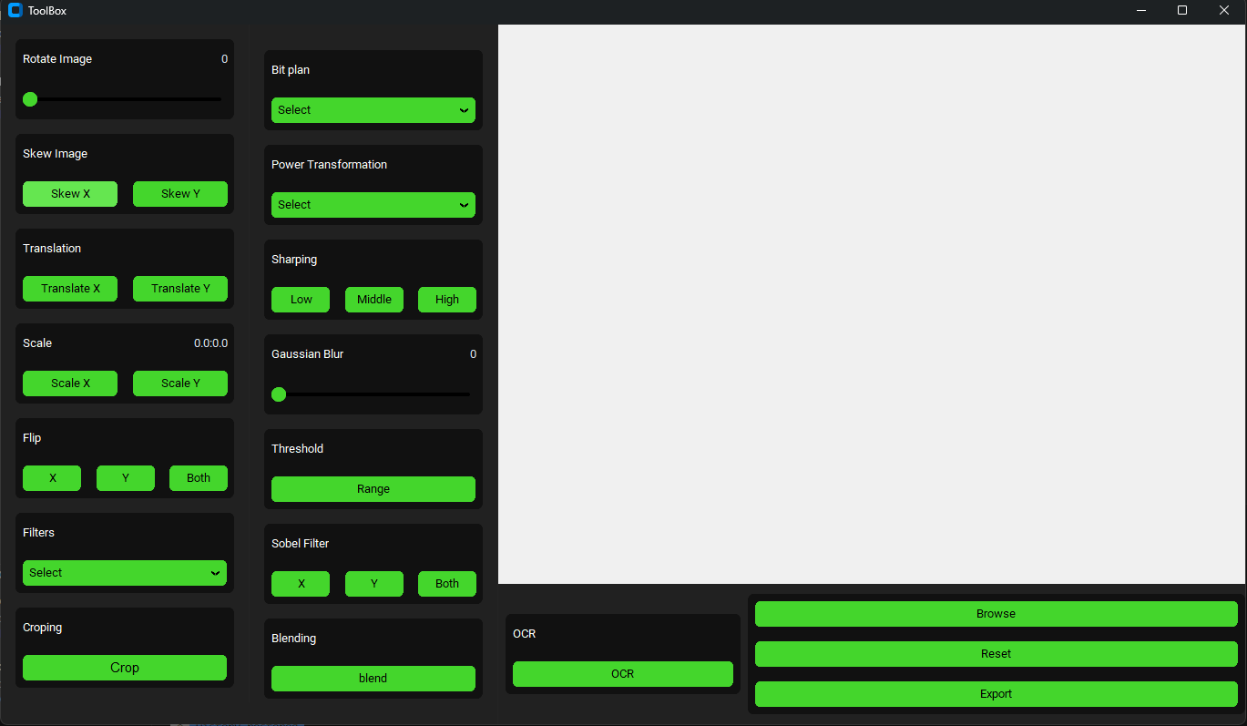

Fifth Every button and component in the program:

Main part

1. Browse 🡪 Used to upload image to toolbox



1. Save image



1. Reset Image to the first upload view



Edit part

1. Rotate the Image

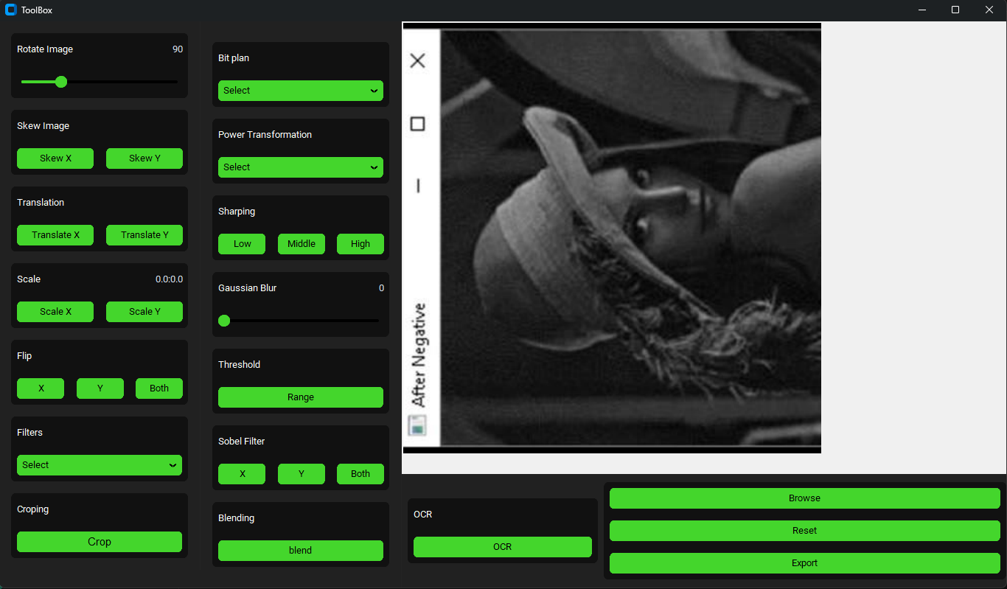

1. Flip Vertical

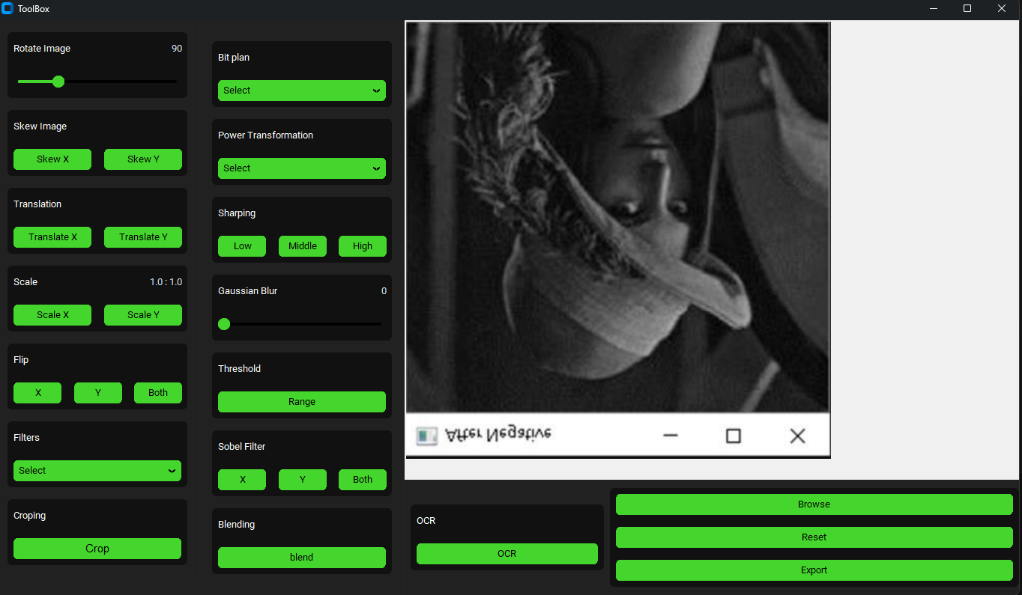

1. Flip horizontal

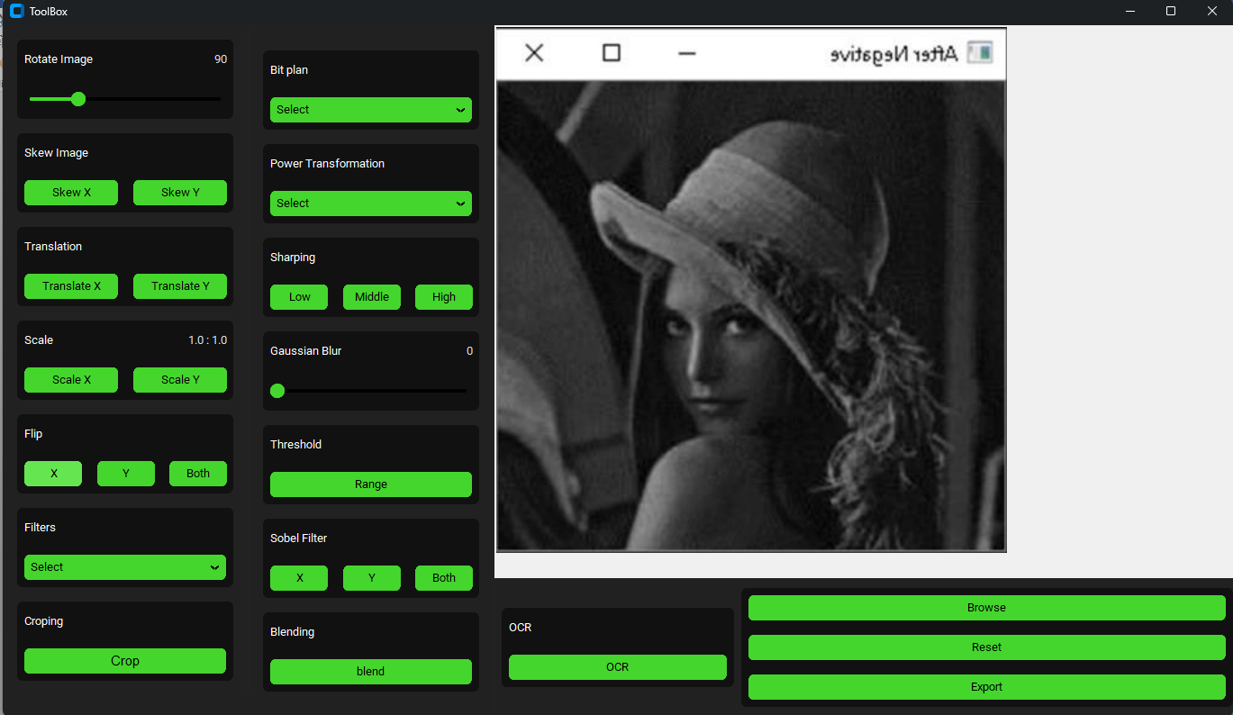

1. Flip Both

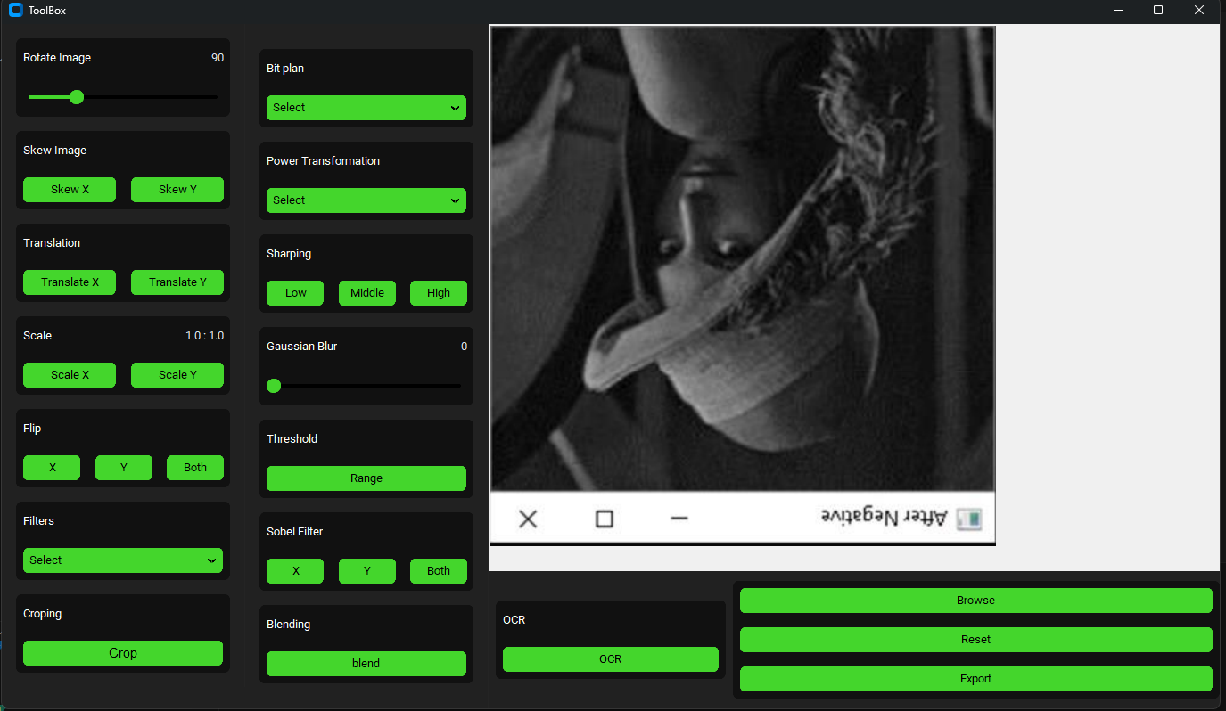

1. Skewing the image

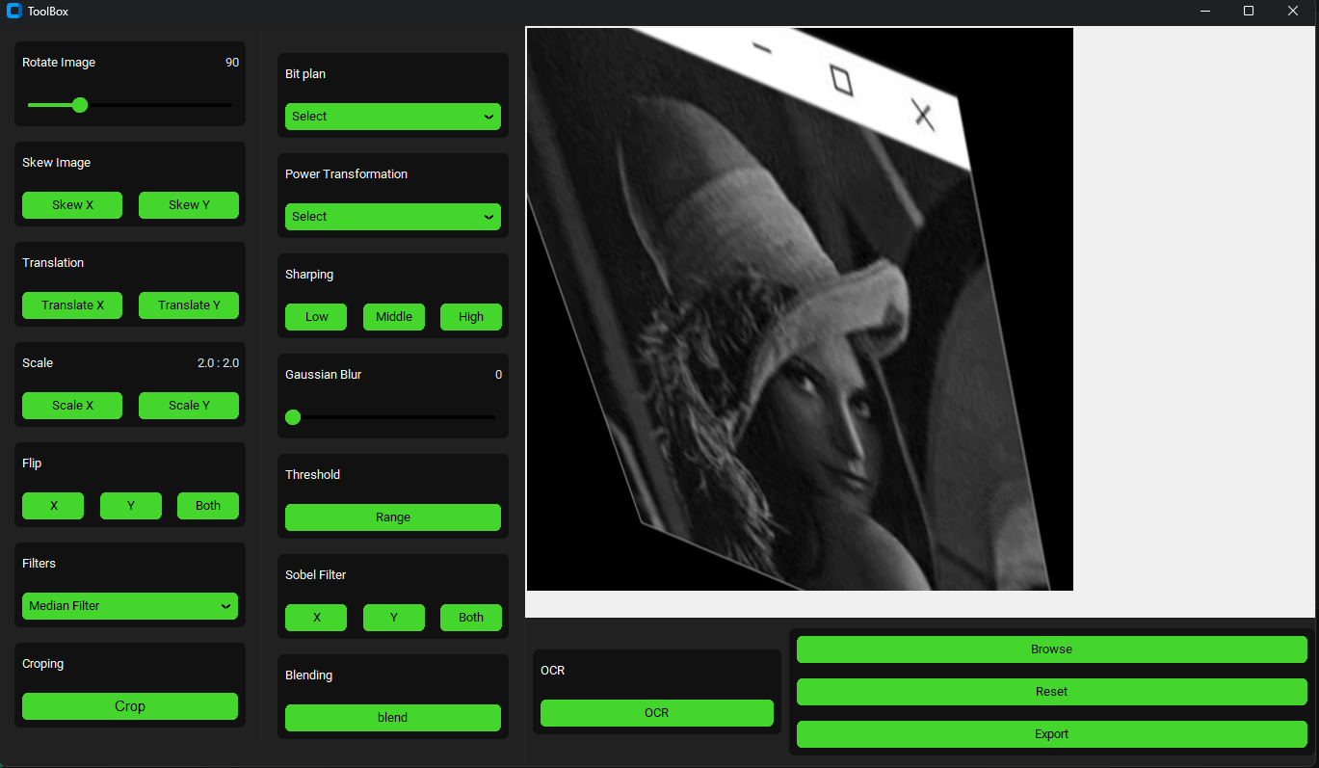

1. Power transformation filter by values (0.1,0.4,0.8,1.2,1.6,2)

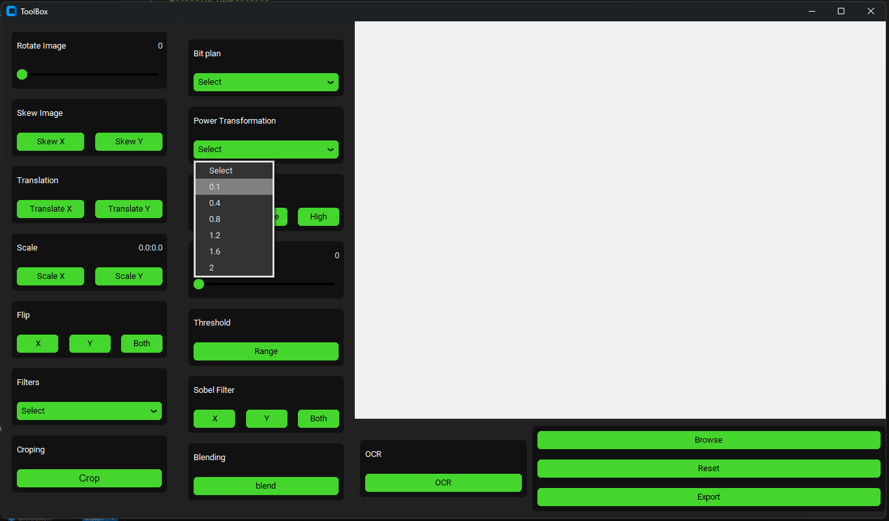

1. Increase or Decrease Size of image

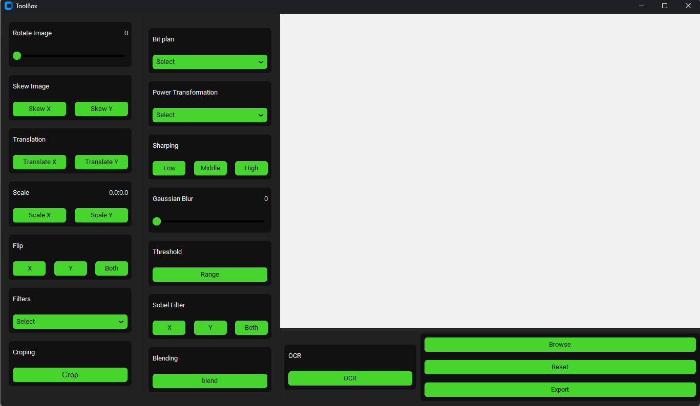

1. Translate image  
   
2. Cropping image



1. Sharping (Low, Middle, High)



1. Bit plane filter with values (128,64,32,16,8,4,2,1)

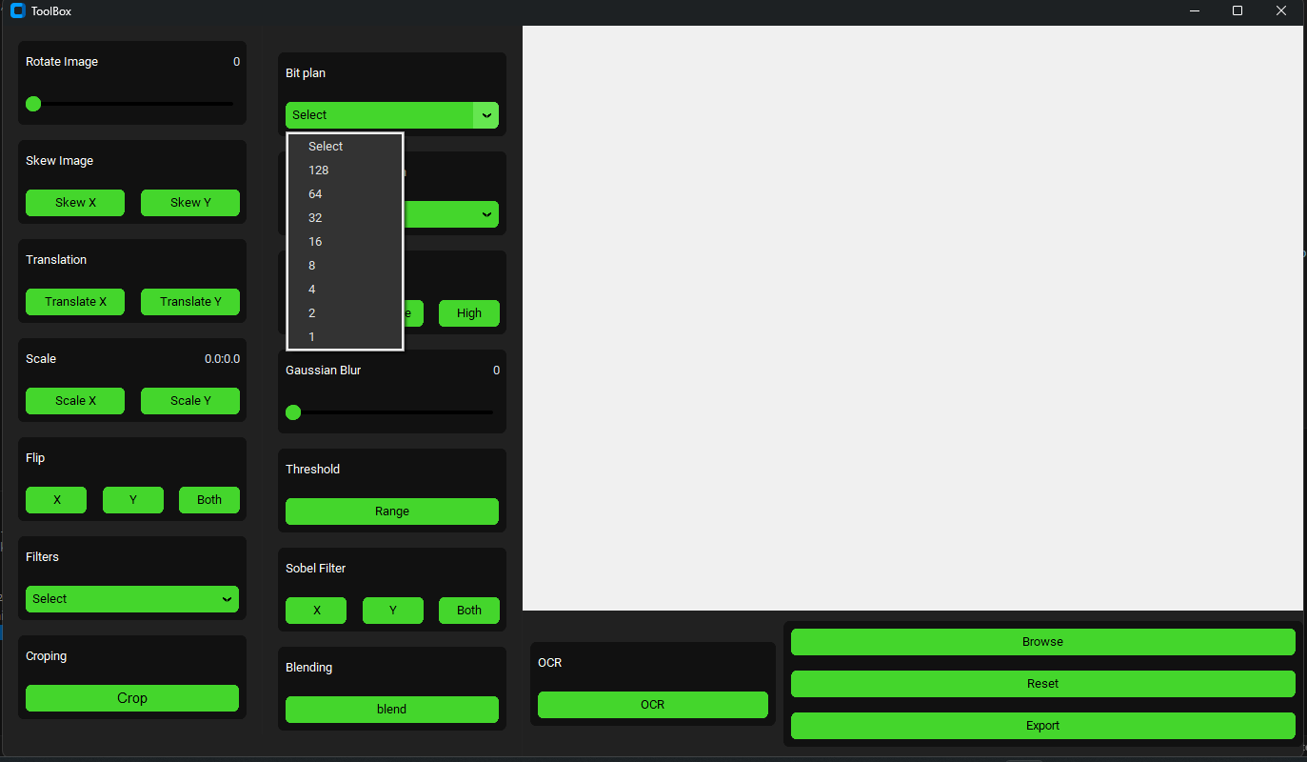

1. Blending 2 images(With Ratios)

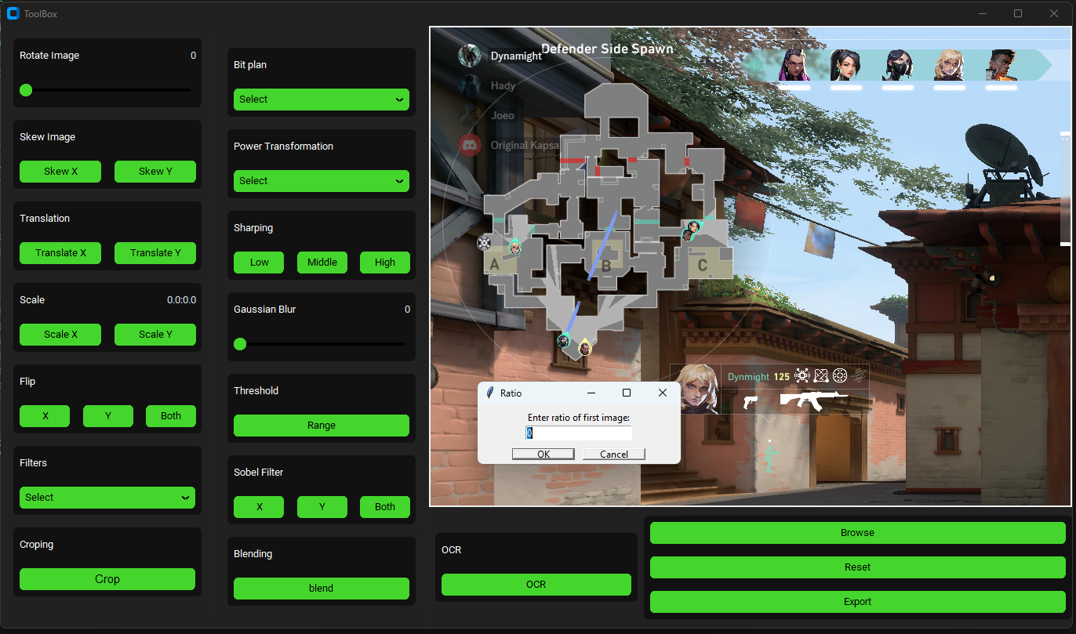

1. Gaussian Blur



1. Threshold(insert value)

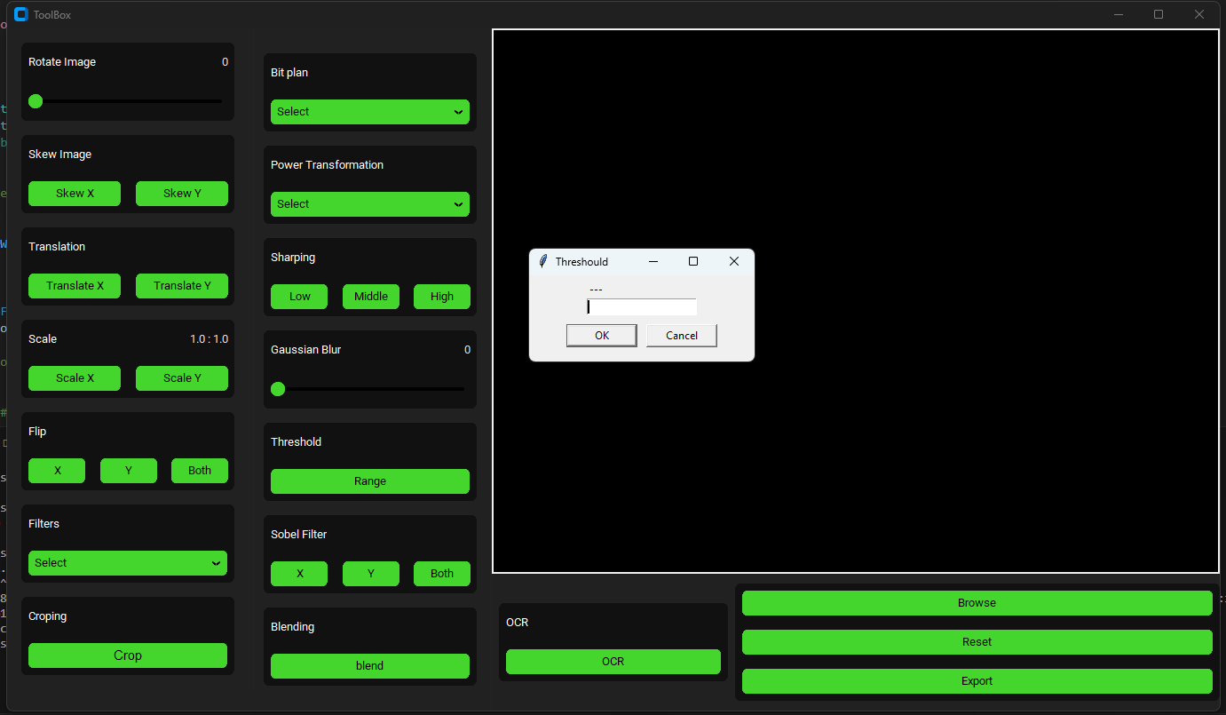

1. Car Plate Detection

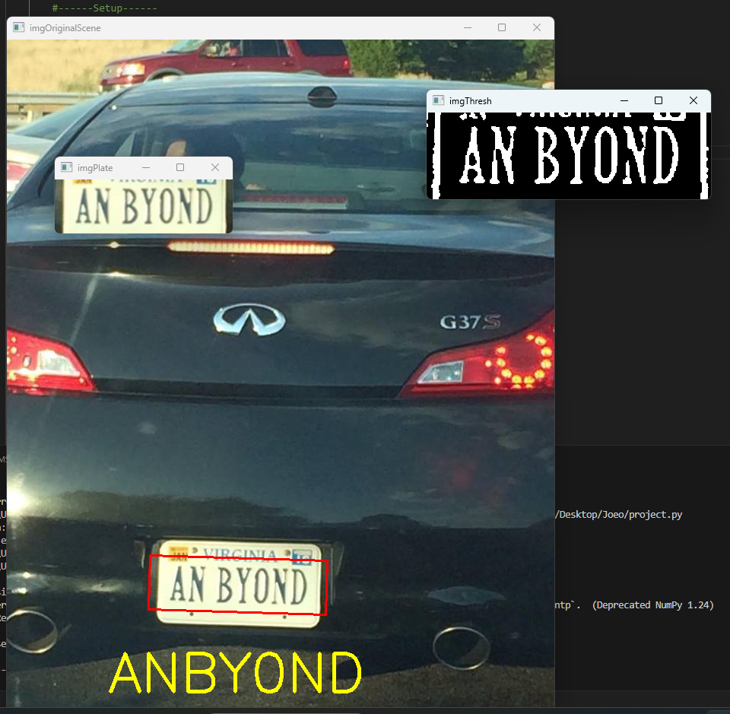

Edge detection part

1. Sobel edge horizontal

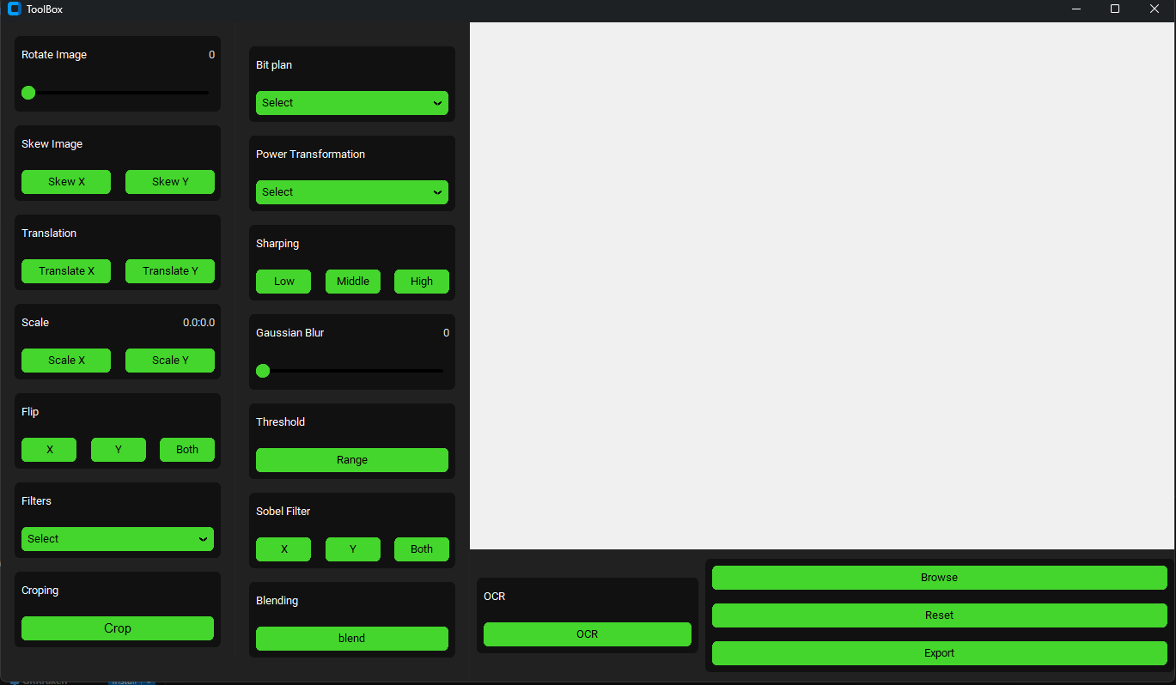

1. Sobel edge vertical



1. Sobel Both



Filter part

1. All available filters (Gray scale, invert, Median filter, Averaging filter, Equalization, Laplacian, Edge Detection) and scale to Motion blur filter.

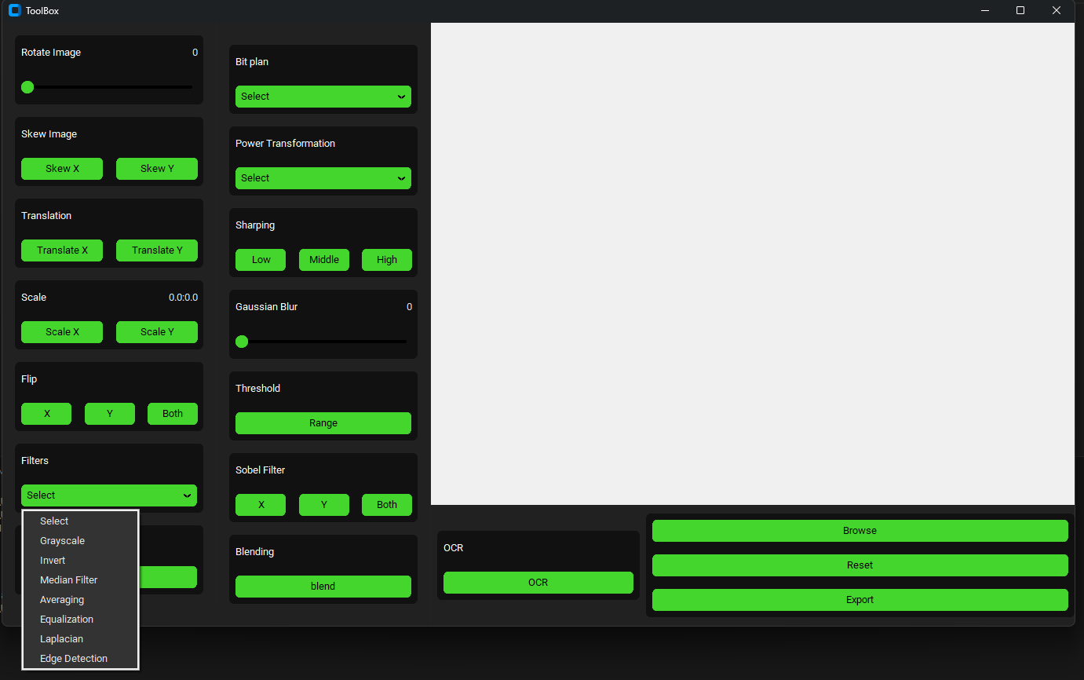

1.GrayScale  
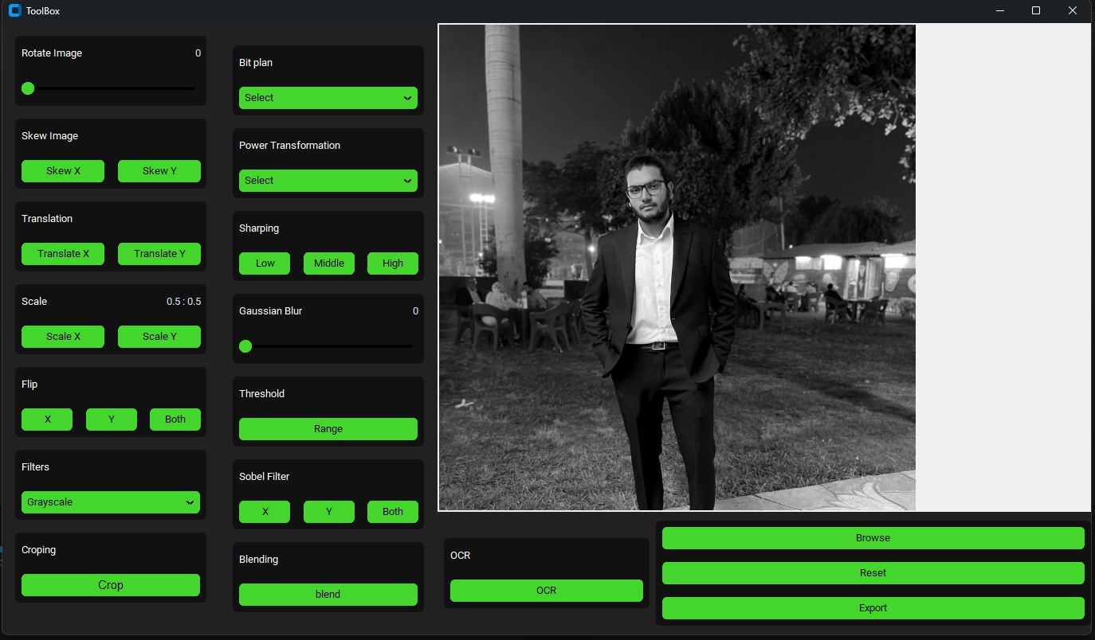

2.invert  
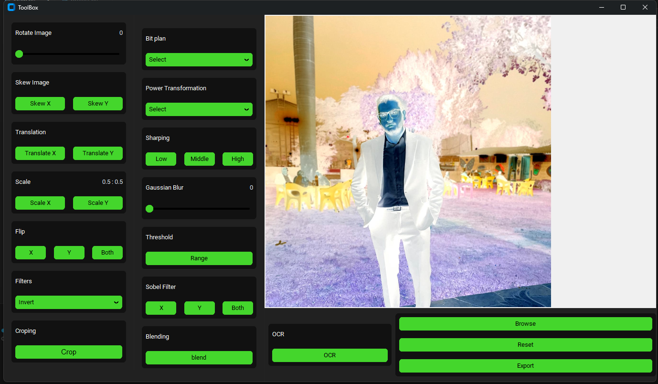

3.Median Filter  
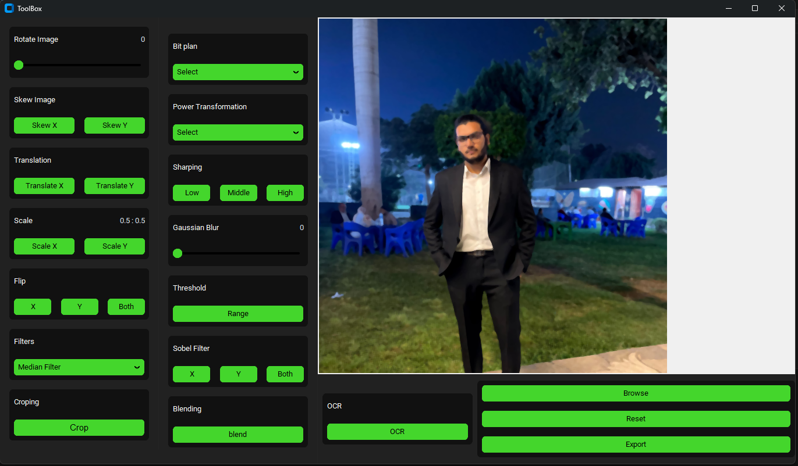

4.Averaging Filter  
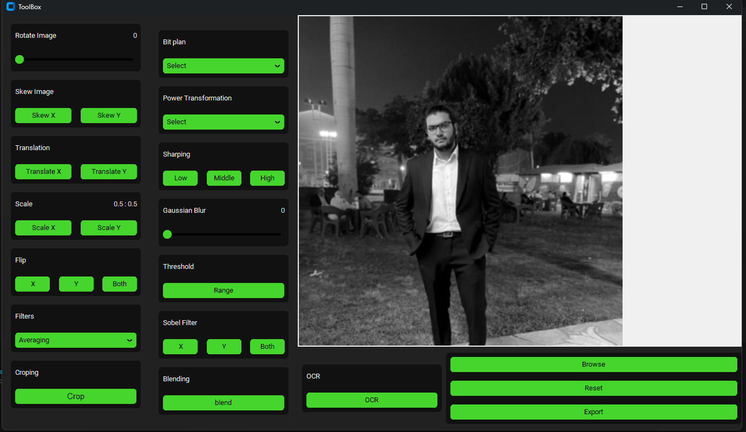

5.Histogram Equalization  
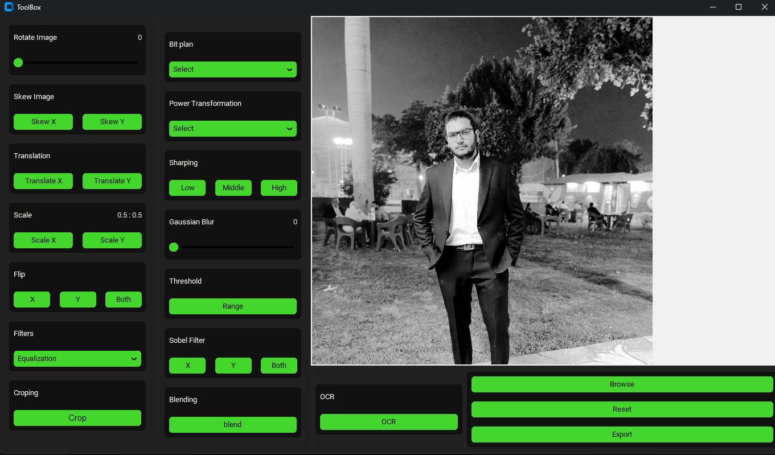

6.Laplacian  
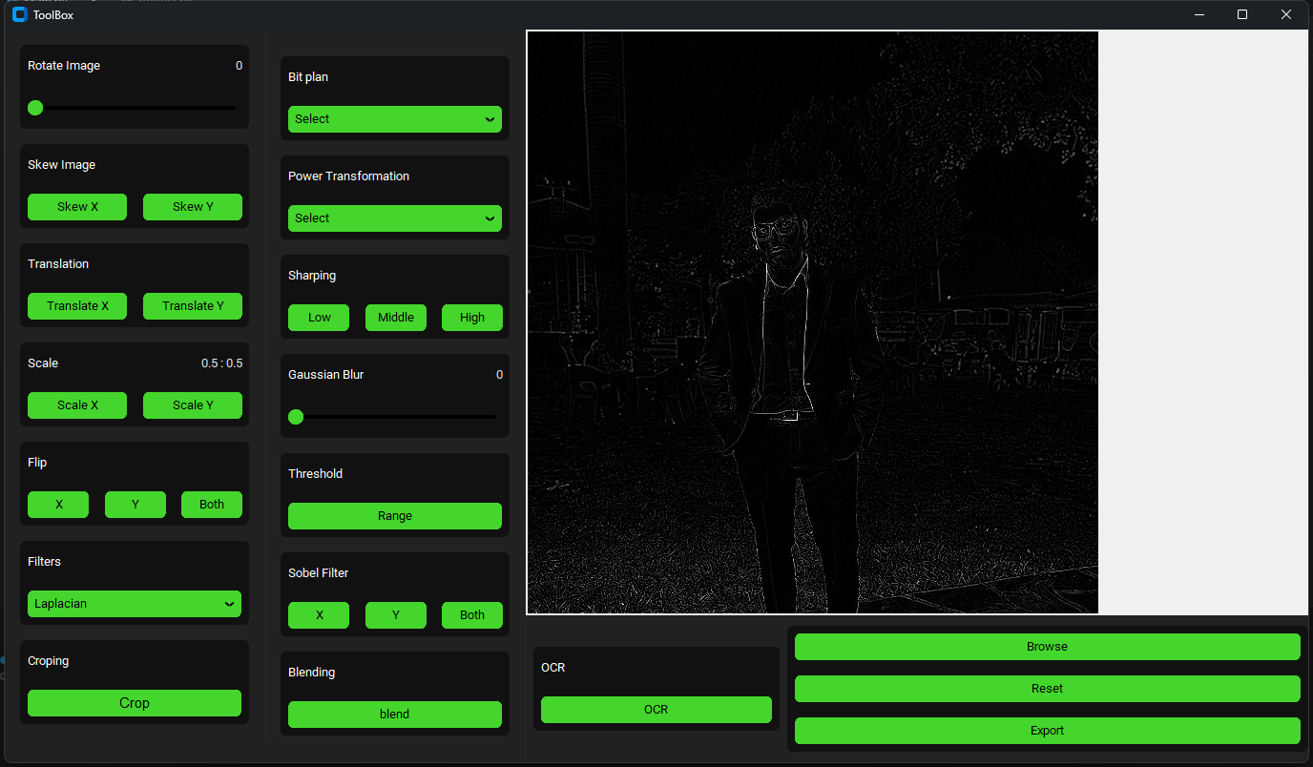

7.Edge Detection  
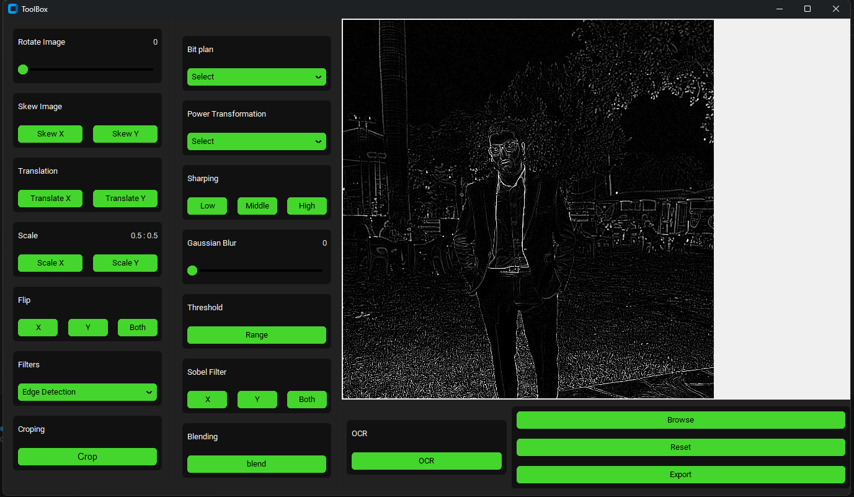

Let’s Try to Enhance These Two images

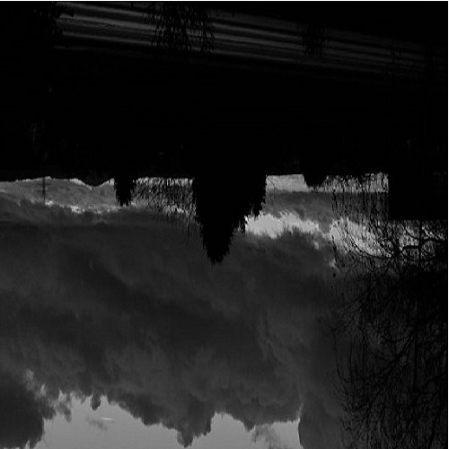 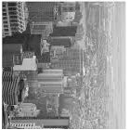

1.First Browse and select the image

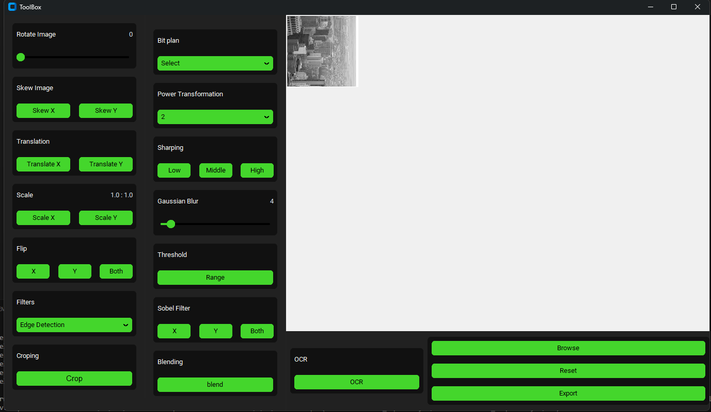

2.Scale X by 4 And Y by 4

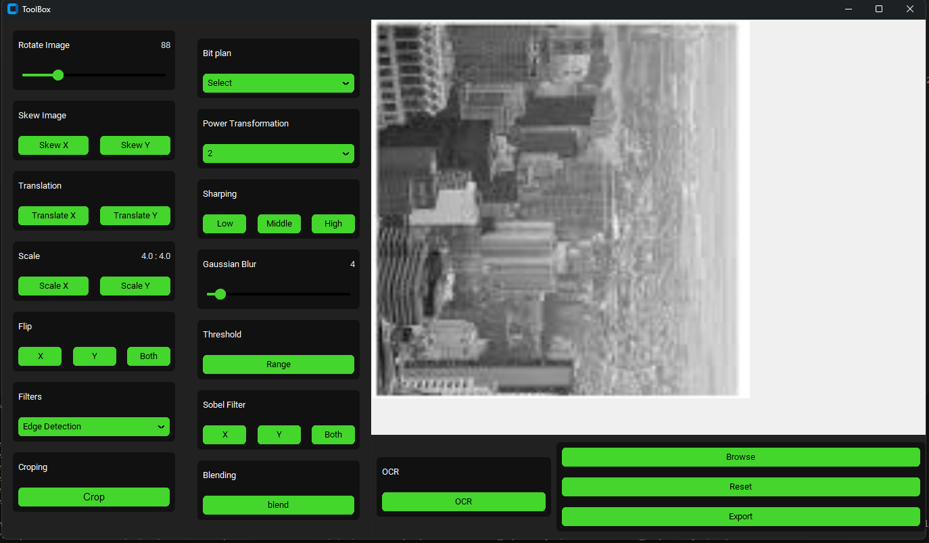

3. Rotate by 90

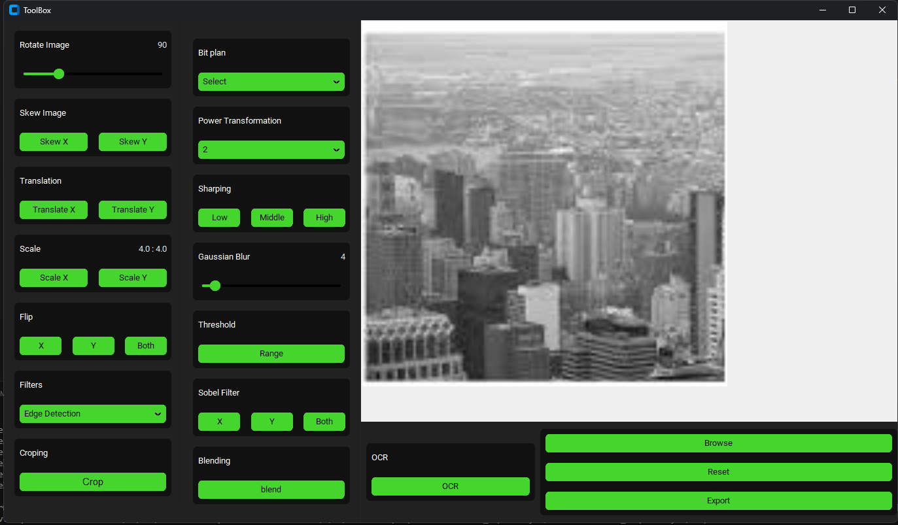

4.Set Power Transformation on 1.6

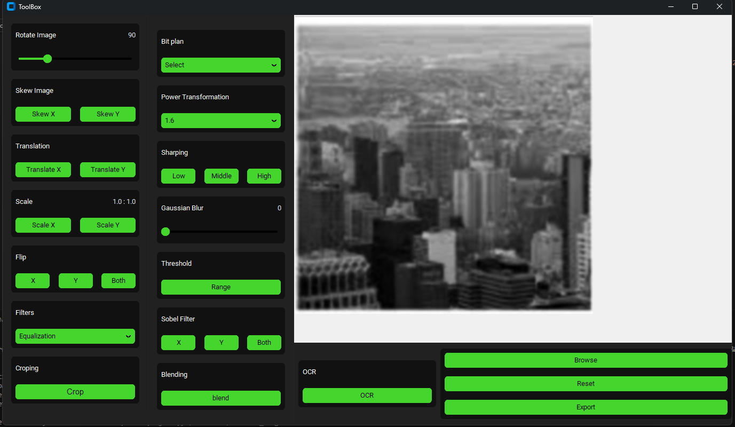

5. Set Gaussian blur on 4  
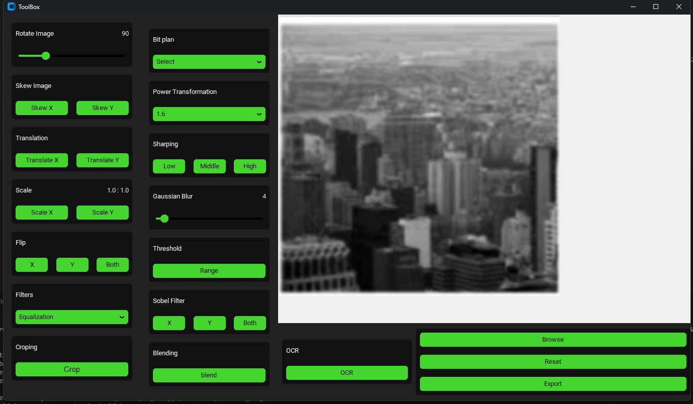

6. Apply Low Sharp

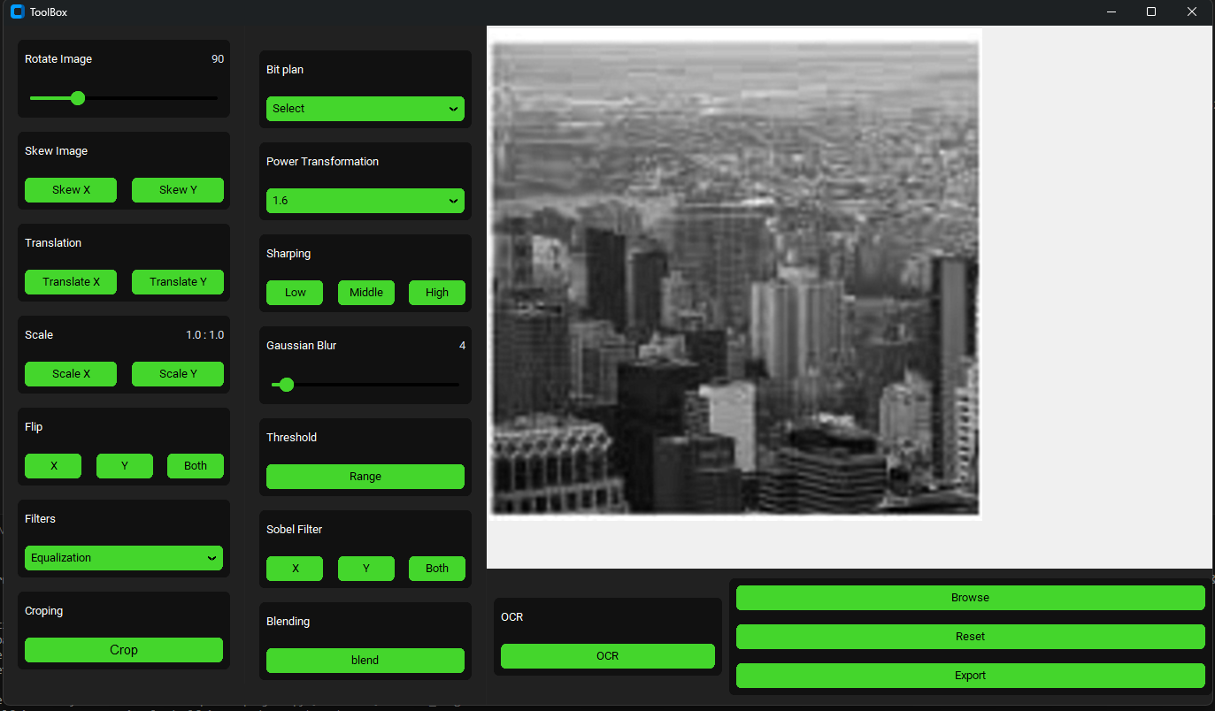

7.Add Equalization Filter  
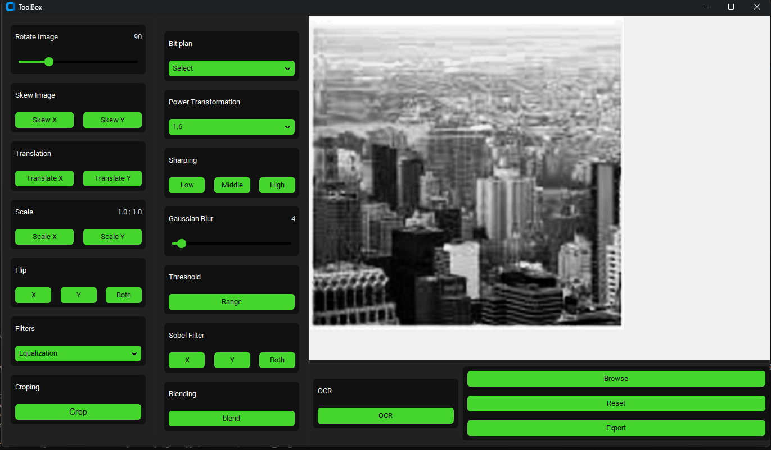

8. Export image  
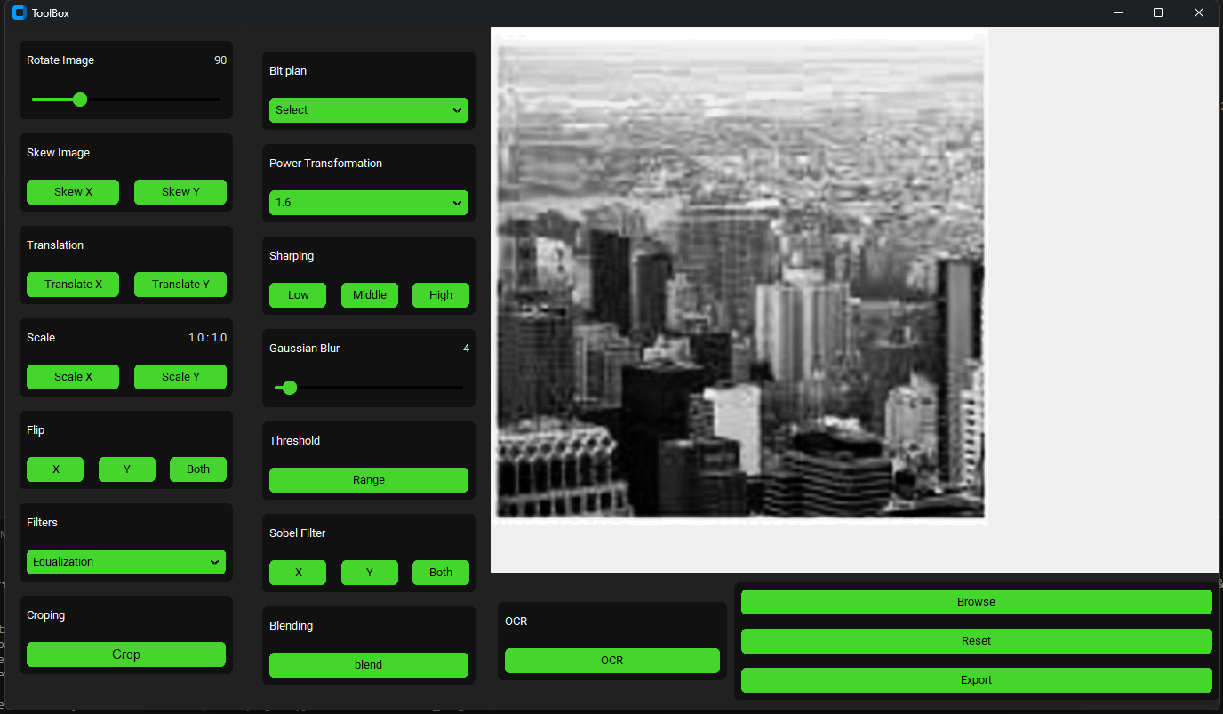

Here is The Final Result

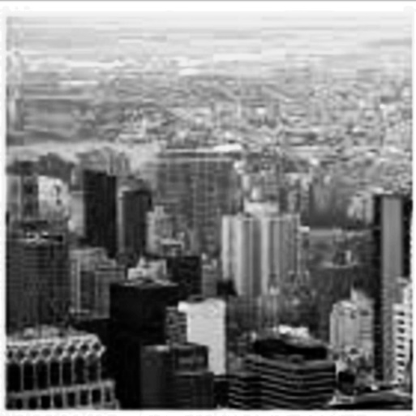

Let’s try to enhance the second image

1.First Browse and select the image

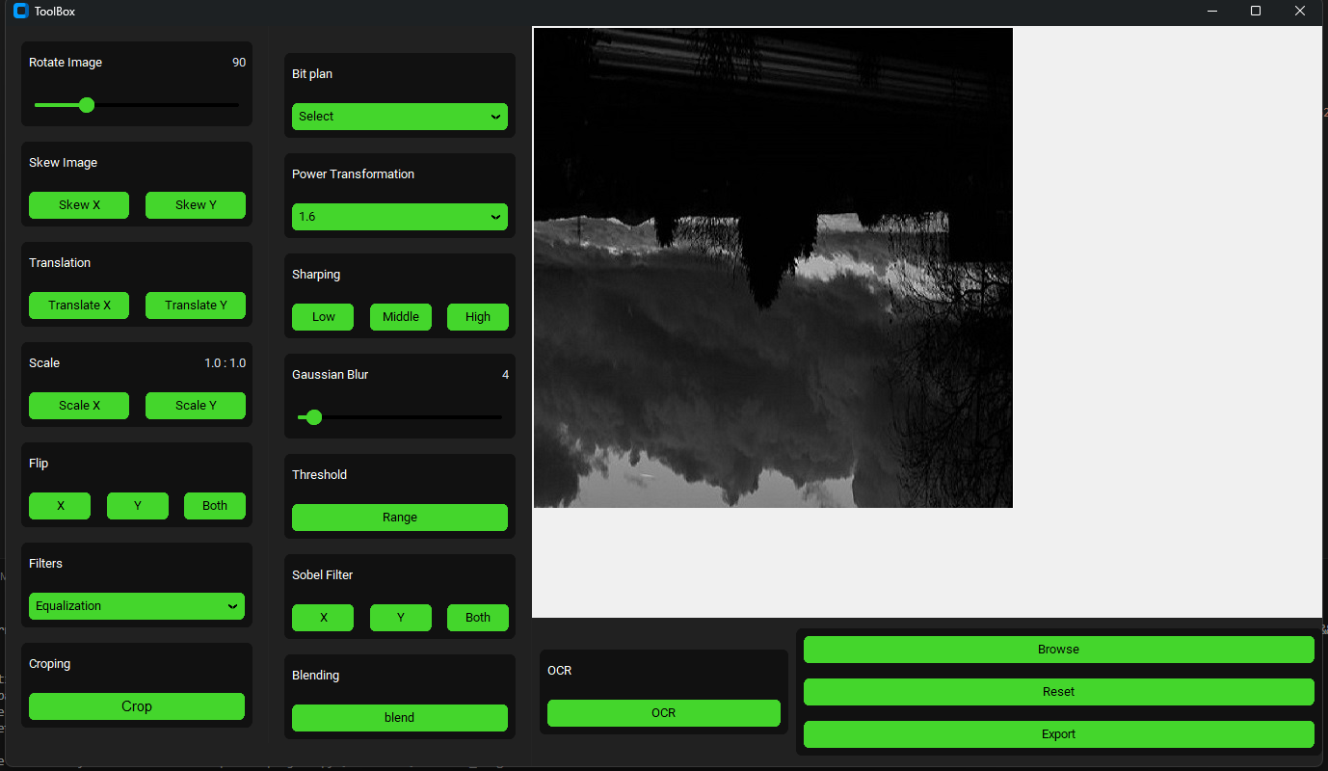

2. Rotate by 180

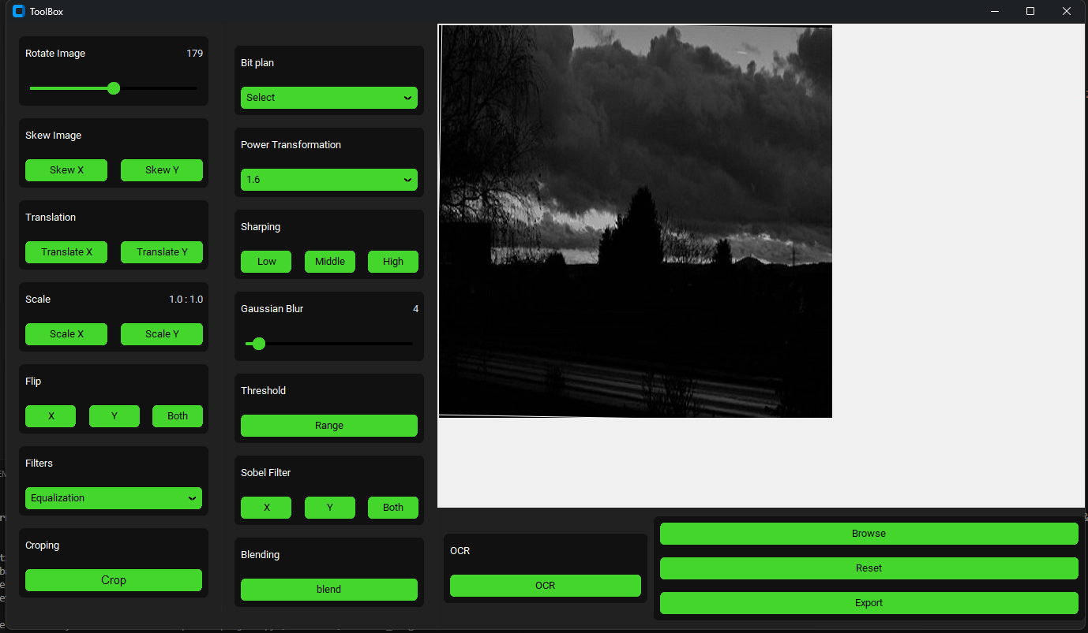

4.Set Power Transformation on 0.8

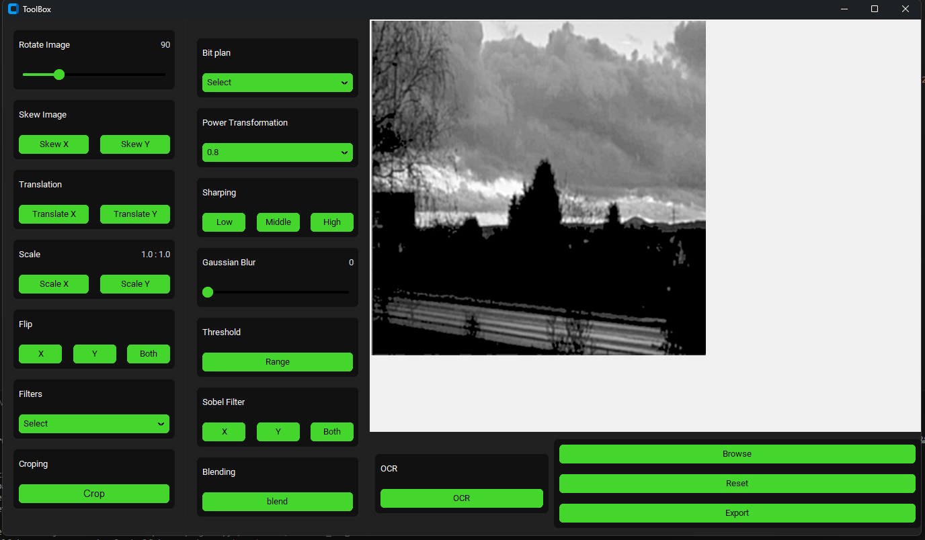

5. Select Averaging Filter  
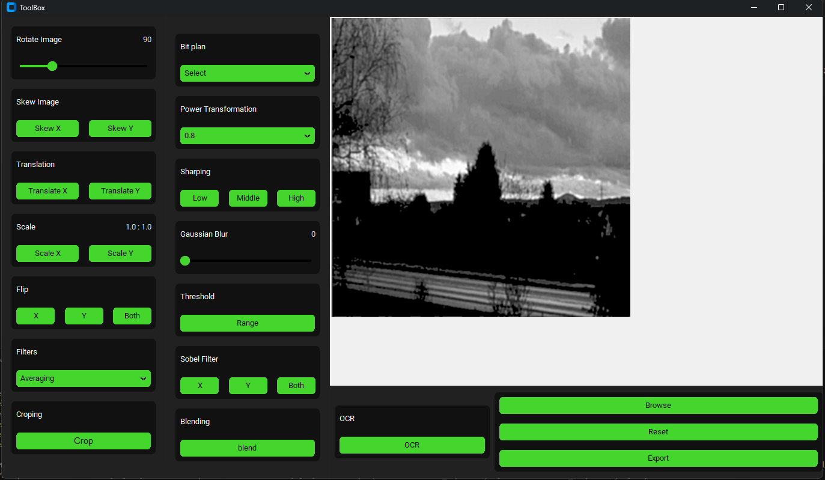

6. Apply Low Sharp

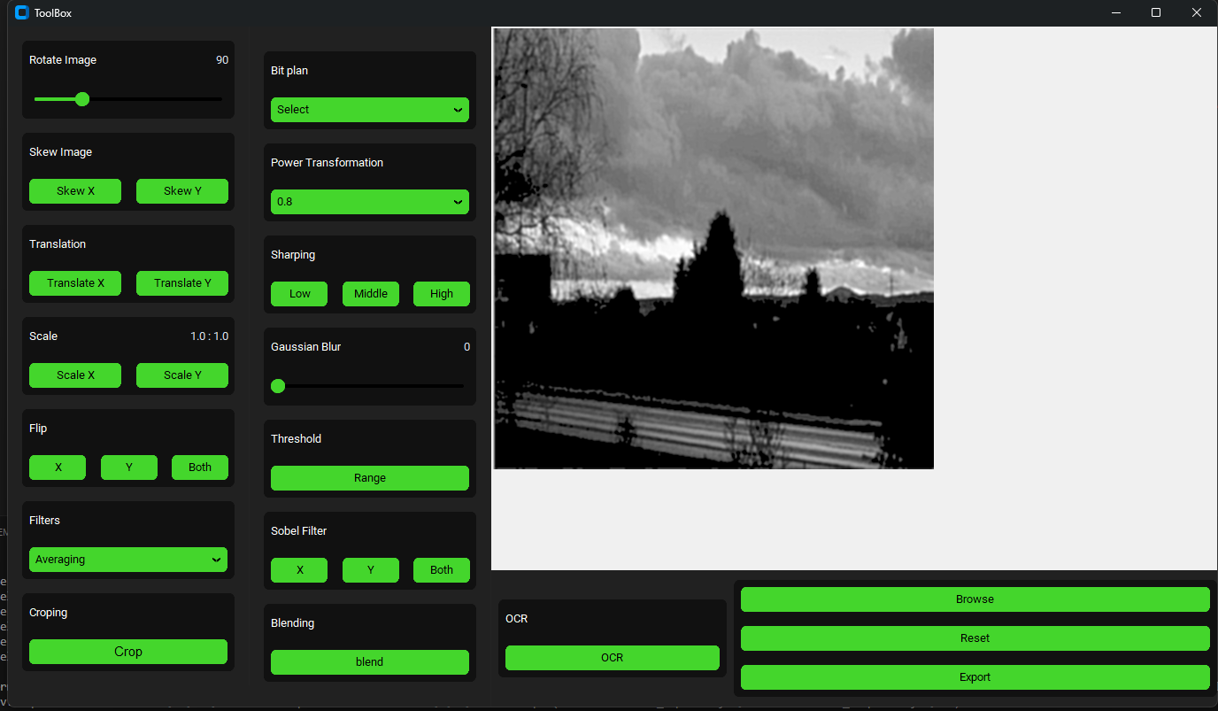

7. Export image  
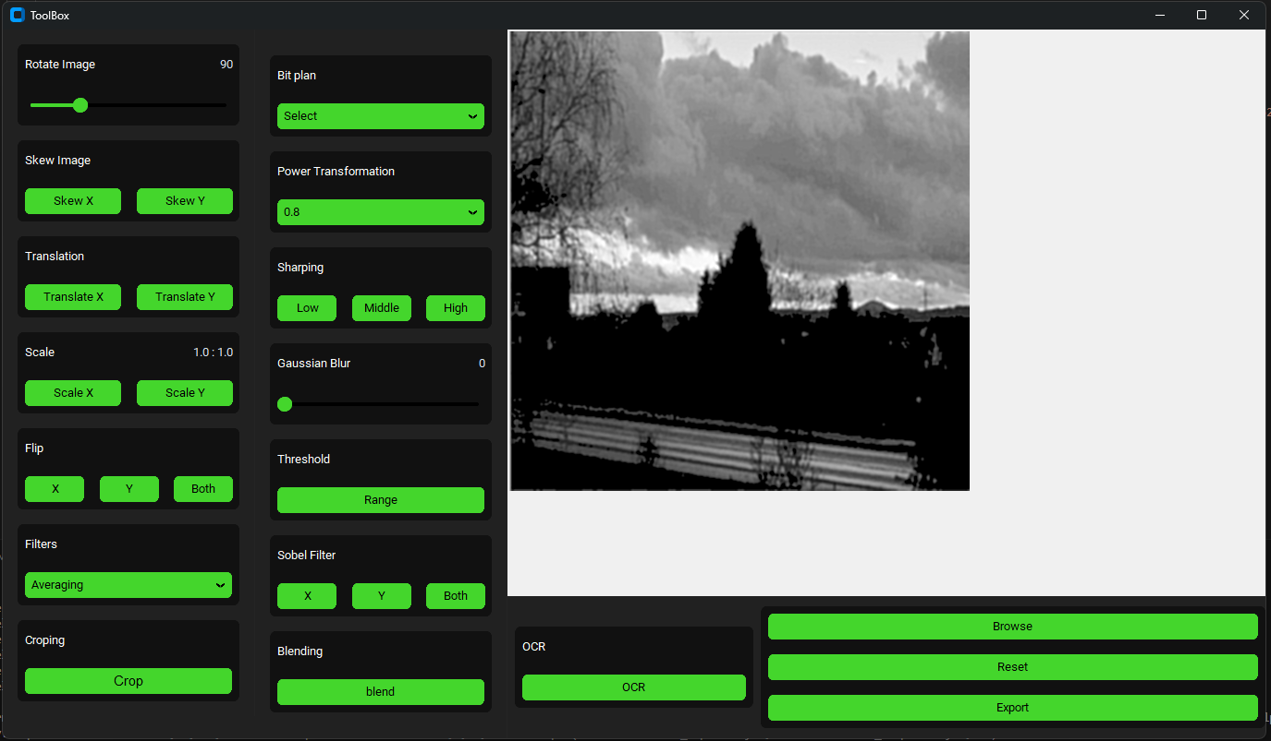

Here is The Final Result

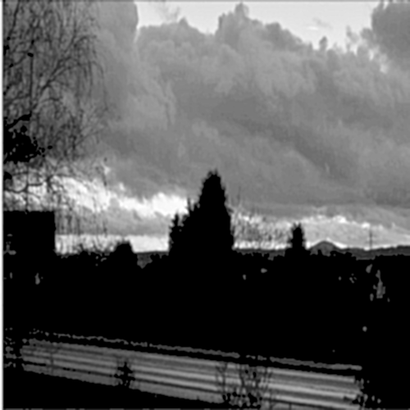

End of Documentation.

Thank You ♥